UNITED STATES
SECURITIES AND EXCHANGE COMMISSION
Washington, D.C. 20549

FORM 8-K

CURRENT REPORT
Pursuant to Section 13 or 15(d)
of the Securities Exchange Act of 1934
Date of Report (Date of earliest event reported): September 15, 2026

Vera Therapeutics, Inc.
(Exact name of registrant as specified in its charter)

Delaware |  | 001-40407 |  | 81-2744449
(State or other jurisdiction  of incorporation) |  | (Commission  File Number) |  | (I.R.S. Employer  Identification No.)

2000 Sierra Point Parkway, Suite 1200  Brisbane, California |  |  |  | 94005
(Address of principal executive offices) |  |  |  | (Zip Code)
(650) 770-0077
(Registrant’s telephone number, including area code)
Not Applicable
(Former name or former address, if changed since last report)

Check the appropriate box below if the Form 8-K filing is intended to simultaneously satisfy the filing obligation of the registrant under any of the following provisions:

☐ | Written communications pursuant to Rule 425 under the Securities Act (17 CFR 230.425)

☐ | Soliciting material pursuant to Rule 14a-12 under the Exchange Act (17 CFR 240.14a-12)

☐ | Pre-commencement communications pursuant to Rule 14d-2(b) under the Exchange Act (17 CFR 240.14d-2(b))

☐ | Pre-commencement communications pursuant to Rule 13e-4(c) under the Exchange Act (17 CFR 240.13e-4(c))
Securities registered pursuant to Section 12(b) of the Act:

Title of each class |  | Trading  Symbol(s) |  | Name of each exchange  on which registered
Class A common stock, $0.001 par value per share |  | VERA |  | The Nasdaq Stock Market LLC
Indicate by check mark whether the registrant is an emerging growth company as defined in Rule 405 of the Securities Act of 1933 (§230.405 of this chapter) or Rule 12b-2 of the Securities Exchange Act of 1934 (§240.12b-2 of this chapter).
Emerging growth company ☐
If an emerging growth company, indicate by check mark if the registrant has elected not to use the extended transition period for complying with any new or revised financial accounting standards provided pursuant to Section 13(a) of the Exchange Act. ☐

Item 7.01 | Regulation FD Disclosure.
On September 15, 2026, Vera Therapeutics, Inc. (the “Company”) announced that TRUTAKNA™ (atacicept-vymj) met all prespecified endpoints of the final efficacy analysis of the ORIGIN 3 trial in adults with primary IgA nephropathy (“IgAN”) at risk for disease progression. A copy of the press release is furnished as Exhibit 99.1. In connection with the data release, the Company updated its corporate presentation (the “Corporate Presentation”) to include the final efficacy analysis of the ORIGIN 3 trial referenced above. A copy of the Corporate Presentation is furnished as Exhibit 99.2. For important information about forward-looking statements, see the slide titled “Forward-Looking Statements” in Exhibit 99.2 attached hereto.
The information in this Item 7.01 of this Current Report on Form 8-K, including Exhibits 99.1 and 99.2, shall not be deemed “filed” for purposes of Section 18 of the Securities Exchange Act of 1934, as amended, or otherwise subject to the liabilities of that section or Sections 11 and 12(a)(2) of the Securities Act of 1933, as amended. The information contained in this Item 7.01, including Exhibits 99.1 and 99.2, shall not be incorporated by reference into any filing with the U.S. Securities and Exchange Commission (“SEC”) made by the Company, whether made before or after the date hereof, regardless of any general incorporation language in such filing.

Item 8.01 | Other Events.
As noted in Item 7.01, on September 15, 2026, the Company announced that TRUTAKNA met all prespecified endpoints of the final efficacy analysis of the ORIGIN 3 trial in adults with primary IgAN at risk for disease progression. Topline results from the final analysis set of 428 patients are presented below.

 |  | TRUTAKNA |  | Placebo |  | Treatment effect |  | p-value
Mean eGFR change from baseline at 52 weeks, mL/min/1.73m2 |  | -0.1  (95% CI -1.4, 1.2) |  | -5.7  (95% CI -7.0, -4.4) |  | 5.6  (95% CI 3.7, 7.5) |  | <0.0001
Annualized eGFR slope through 104 weeks, mL/min/1.73m2/year |  | -0.6  (95% CI -1.6, 0.4) |  | -5.6  (95% CI -6.6, -4.6) |  | 5.0  (95% CI 3.6, 6.5) |  | <0.0001
Composite kidney disease progression event through 104 weeks, n |  | 11 |  | 38 |  | Hazard ratio 0.24  (95% CI 0.12, 0.48)  76% risk reduction |  | <0.0001
Dialysis ≥30 days, transplant, or death through 104 weeks, n |  | 0 |  | 8
These estimated glomerular filtration rate (“eGFR”) results align with the KDIGO treatment goal to reduce the rate of kidney function decline to the physiologic rate (<1 mL/min/1.73m2/year). TRUTAKNA also achieved statistically significant reductions in the hierarchically tested endpoints of proteinuria, galactose-deficient IgA1, and hematuria. TRUTAKNA was well tolerated with a favorable safety profile generally comparable to placebo, consistent with previous results from the ORIGIN program. Rates of overall adverse events and infections or infestations were similar between the TRUTAKNA and placebo groups, and there were no opportunistic infections or clinically relevant hypogammaglobulinemia.

2

Item 9.01 | Financial Statements and Exhibits.
(d) Exhibits.

Exhibit  No. |  | Description
99.1 |  | Press Release of Vera Therapeutics, Inc., dated September 15, 2026
99.2 |  | Corporate Presentation, dated September 15, 2026
104 |  | Cover Page Interactive Data File (embedded within the Inline XBRL document).

3

SIGNATURES
Pursuant to the requirements of the Securities Exchange Act of 1934, as amended, the registrant has duly caused this report to be signed on its behalf by the undersigned hereunto duly authorized.

 |  |  |  | Vera Therapeutics, Inc.
Dated: September 15, 2026
 |  |  |  | By: |  | /s/ Marshall Fordyce
 |  |  |  |  |  | Marshall Fordyce, M.D.
 |  |  |  |  |  | Chief Executive Officer

4
Exhibit 99.1
Vera Therapeutics Announces TRUTAKNA (atacicept-vymj) Stabilized eGFR and Prevented Kidney Disease Progression Through Two Years in ORIGIN 3 Final Efficacy Analysis in IgA Nephropathy

 |  |  | TRUTAKNA, the first and only FDA-approved BAFF and APRIL inhibitor, met all prespecified endpoints, including unprecedented placebo-adjusted estimated glomerular filtration rate (eGFR) and composite kidney disease progression benefits.

 |  |  | Favorable safety profile, and generally comparable to placebo.

 |  |  | Strong commercial launch momentum with over 350 patient start forms generated in the first ten weeks.

 |  |  | Plan to submit supplemental BLA to the U.S. Food and Drug Administration (FDA) for full approval in Q4 2026.
BRISBANE, Calif., September 15, 2026 – Vera Therapeutics, Inc. (Nasdaq: VERA), a commercial-stage biotechnology company, today announced that TRUTAKNA met all prespecified endpoints of the final efficacy analysis of the ORIGIN 3 trial in adults with primary IgA nephropathy (IgAN) at risk for disease progression. Topline results from the final analysis set of 428 patients are presented below.

 |  | TRUTAKNA |  | Placebo |  | Treatment effect |  | p-value
Mean eGFR change from baseline at 52 weeks, mL/min/1.73m2 |  | -0.1  (95% CI -1.4, 1.2) |  | -5.7  (95% CI -7.0, -4.4) |  | 5.6  (95% CI 3.7, 7.5) |  | <0.0001
Annualized eGFR slope through 104 weeks, mL/min/1.73m2/year |  | -0.6  (95% CI -1.6, 0.4) |  | -5.6  (95% CI -6.6, -4.6) |  | 5.0  (95% CI 3.6, 6.5) |  | <0.0001
Composite kidney disease progression event through 104 weeks, n |  | 11 |  | 38 |  | Hazard ratio 0.24  (95% CI 0.12, 0.48)  76% risk reduction |  | <0.0001
Dialysis ≥30 days, transplant, or death through 104 weeks, n |  | 0 |  | 8
These eGFR results align with the KDIGO treatment goal to reduce the rate of kidney function decline to the physiologic rate (<1 mL/min/1.73m2/year).1 TRUTAKNA also achieved statistically significant reductions in the hierarchically tested endpoints of proteinuria, galactose-deficient IgA1 (Gd-IgA1), and hematuria. TRUTAKNA was well tolerated with a favorable safety profile generally comparable to placebo, consistent with previous results from the ORIGIN program.2 Rates of overall adverse events and infections or infestations were similar between the TRUTAKNA and placebo groups, and there were no opportunistic infections or clinically relevant hypogammaglobulinemia. Detailed results from the final efficacy analysis will be shared at an upcoming scientific congress.
“The ORIGIN 3 final analysis, demonstrating a significant reduction in risk of composite kidney disease progression, true stabilization of eGFR, and a favorable safety profile through two years, marks a milestone in IgAN treatment,” said Richard Lafayette, M.D., F.A.C.P., Professor of Medicine, Nephrology and Director of the Glomerular Disease Center at Stanford University Medical Center, and a principal investigator for ORIGIN 3. “Prevention of kidney failure or kidney-related death is the ultimate goal. We now have evidence suggesting that TRUTAKNA may help patients avoid dialysis, transplantation, or kidney-related death over the long term.”
“We believe that upstream inhibition of BAFF and APRIL with TRUTAKNA achieves results that reflect the potential for comprehensive disease modification in IgAN. ORIGIN 3 is the first reported Phase 3 IgAN trial to reach alignment with the FDA on an earlier final efficacy analysis, offering patients randomized to placebo an earlier opportunity to transition to open-label TRUTAKNA. The final results support this alignment and we plan to submit the supplemental BLA in the fourth quarter of this year. We look forward to the potential full approval of TRUTAKNA in 2027,” said Marshall Fordyce, M.D., Founder and CEO of Vera Therapeutics. “We reiterate our gratitude to the patients, investigators, employees, and collaborators who have helped us to deliver a transformative therapy to patients in need.”

“We are excited for the upcoming supplemental BLA submission based on the ORIGIN 3 final analysis. Since receiving accelerated approval, we have seen significant interest from the IgAN community. In the first ten weeks, we have generated over 350 patient start forms. We are seeing paid claims and are pleased with initial payer policies. The early momentum of the TRUTAKNA launch is very encouraging,” said Matt Skelton, Chief Commercial Officer of Vera Therapeutics.
About IgAN
IgAN is a serious, progressive, immune-mediated kidney disease and a leading cause of chronic kidney disease and kidney failure worldwide.3,4 Approximately 2.5 adults per 100,000 worldwide are diagnosed with IgAN each year, most often between 30 and 40 years of age.5,6 Over time, IgAN can lead to irreversible kidney damage and may ultimately require dialysis or kidney transplantation. At least 50% of patients may progress to kidney failure or death within 10 to 20 years of diagnosis.4
About TRUTAKNA (atacicept-vymj)
TRUTAKNA, a B-cell activating factor (BAFF) and A proliferation-inducing ligand (APRIL) inhibitor, is a soluble recombinant fusion protein containing the human transmembrane activator and calcium-modulating cyclophilin ligand interactor (TACI) receptor that binds to the cytokines BAFF and APRIL.7 BAFF and APRIL are key cytokines that activate B cells and drive IgAN pathophysiology. In IgAN, activated B cells produce both the antigen and associated antibodies that result in the production of damaging IgA immune complexes. The overlapping roles of BAFF and APRIL in activating B cells support the potential for TRUTAKNA as a disease-modifying therapy.3 TRUTAKNA is self-administered as an at-home, small-volume (1 ml), 150 mg once-weekly autoinjector.
Indication
TRUTAKNA (atacicept-vymj) is indicated to reduce proteinuria in adults with primary immunoglobulin A nephropathy (IgAN) at risk for disease progression.
This indication is approved under accelerated approval based on reduction of proteinuria. It has not been established whether TRUTAKNA slows kidney function decline over the long-term in patients with IgAN. Continued approval for this indication may be contingent upon verification and description of clinical benefit in a confirmatory clinical trial.
Important Safety Information
Contraindications: TRUTAKNA is contraindicated in patients with serious hypersensitivity to atacicept-vymj or any excipients of TRUTAKNA.
Warnings and Precautions
Immunosuppression and Increased Risk of Infections: TRUTAKNA suppresses the immune system by reducing antibody production, which may increase the risk of infections. Patients with chronic infection or recurring infections may have an increased risk of serious infection. In clinical trials, infections were reported in 32% of TRUTAKNA patients compared with 28% of placebo patients.
Before initiating TRUTAKNA, assess patients for active infections. Delay TRUTAKNA administration in patients with active infection until the infection resolves or is adequately treated. Monitor patients for signs and symptoms of infection during treatment with TRUTAKNA. If a serious infection develops, consider interrupting TRUTAKNA until the infection is controlled.
The concomitant use of TRUTAKNA and other immune-modulating therapies has not been evaluated. Concomitant use of TRUTAKNA with drugs that affect the immune system, including systemic corticosteroids, may increase the risk of infection.
Immunosuppression and Immunization Risk: TRUTAKNA may interfere with the immune response to vaccines and increase the risk of infection from live vaccines. Prior to initiating treatment with TRUTAKNA, complete all age-appropriate immunizations. Live vaccines are not recommended within 30 days prior to initiation or during treatment with TRUTAKNA as safety of coadministration has not been established.

Adverse Reactions: The most common adverse reactions (≥5%) in patients treated with TRUTAKNA and placebo, respectively, were infections (32% vs 28%) and local administration reactions (30% vs 5%). The most common infection was upper respiratory tract infection (12% vs 9%), and the most common local administration reactions were injection site reaction (19% vs 2%) and injection site erythema (6% vs 1%).
Use in Specific Populations
Pregnancy: Available data on TRUTAKNA used in pregnant women exposed during clinical trials are insufficient to evaluate for a drug-associated risk of major birth defects, miscarriage, or other adverse maternal or fetal outcomes.
Based on the mechanism of action, TRUTAKNA may cause immunosuppression in the in utero-exposed infant. Consider the potential clinical impact of TRUTAKNA exposure in infants exposed in utero. Pregnant women exposed to TRUTAKNA, or their healthcare provider, should report TRUTAKNA exposure by calling 1-833-633-8372.
Pediatric Use: The safety and effectiveness of TRUTAKNA in pediatric patients have not been established.
You may report side effects to the FDA at 1-800-FDA-1088 or www.fda.gov/medwatch. You may also report side effects to Vera Therapeutics at 1-833-MED-VERA or medinfo@veratx.com.
Please see full Prescribing Information for additional Important Safety Information.
TRUTAKNA TRU SUPPORT Patient Support Program
We are dedicated to ensuring that eligible IgAN patients can access the first approved therapy that targets both BAFF and APRIL. TRUTAKNA TRU SUPPORT, our patient support program, offers insurance coverage assistance, financial assistance options for eligible patients, and educational resources designed to support patient access and care. Eligible commercially insured patients may pay as little as $0 out of pocket through our copay assistance program. More information will be available on www.veratx.com.
About Vera Therapeutics
Vera Therapeutics is a commercial-stage biotechnology company focused on the pursuit of truth in science to transform medicine in autoimmune disease, starting with the kidney. Vera Therapeutics’ flagship commercial product is TRUTAKNA (atacicept-vymj), a BAFF and APRIL inhibitor indicated to reduce proteinuria in adults with primary IgA nephropathy at risk for disease progression. Beyond IgAN, Vera Therapeutics is evaluating additional diseases where the reduction of autoantibodies through inhibition of BAFF and APRIL may prove clinically meaningful. Vera Therapeutics was founded in 2016 and is based in Brisbane, California. To learn more, visit www.veratx.com.
Forward-looking Statements
Statements contained in this press release regarding matters, events or results that may occur in the future are “forward-looking statements” within the meaning of the Private Securities Litigation Reform Act of 1995. Such forward-looking statements include statements regarding, among other things, the ability of TRUTAKNA to stabilize eGFR and prevent kidney disease progression; the strength of Vera Therapeutics’ commercial launch momentum for TRUTAKNA; the plan to submit a supplemental BLA to the FDA in the fourth quarter of 2026 for full approval; the timing for the detailed results from the final efficacy analysis to be shared at an upcoming scientific congress; the ability of the ORIGIN 3 final analysis to mark a milestone in IgAN treatment; the ability for the upstream inhibition of BAFF and APRIL with TRUTAKNA to achieve results that reflect comprehensive disease modification in IgAN; the ability of TRUTAKNA to help patients avoid dialysis, transplantation, or kidney-related death over the long term; the potential for the FDA to grant full approval to TRUTAKNA and the timing of such approval; the interest the IgAN community has in TRUTAKNA; the potential success of the TRUTAKNA launch; and the plans, commitments, aspirations and goals under the caption “About Vera Therapeutics”. Words such as “anticipate,” “believe,” “expect,” “may,” “plan,” “potential,” “will” and similar expressions are intended to identify forward-looking statements. These forward-looking statements are based upon Vera Therapeutics’ current expectations and involve assumptions that may never materialize or may prove to be incorrect. Actual results could differ materially from those anticipated in such forward-looking statements as a result of various risks and uncertainties, which include, without limitation, risks related to the regulatory approval process, risks related to commercial launch, market acceptance, and payer coverage, results of earlier clinical trials may not be obtained in later clinical trials,

preliminary results may not be predictive of topline results, risks and uncertainties associated with Vera Therapeutics’ business in general, the impact of macroeconomic and geopolitical events, and the other risks described in Vera Therapeutics’ filings with the U.S. Securities and Exchange Commission. All forward-looking statements contained in this press release speak only as of the date on which they were made and are based on management’s assumptions and estimates as of such date. Vera Therapeutics undertakes no obligation to update such statements to reflect events that occur or circumstances that exist after the date on which they were made, except as required by law.
References
1. Kidney Disease: Improving Global Outcomes (KDIGO) IgAN and IgAV Work Group. KDIGO 2025 Clinical Practice Guideline for the Management of Immunoglobulin A Nephropathy (IgAN) and Immunoglobulin A Vasculitis (IgAV). Kidney Int. 2025;108(4S):S1-S71.
2. Lafayette R, Barbour SJ, Brenner RM, et al. A Phase 3 Trial of Atacicept in Patients with IgA Nephropathy. N Engl J Med. 2026;394(7):647-657. doi:10.1056/NEJMoa2510198
3. Cheung CK, Barratt J, Liew A, Zhang H, Tesar V, Lafayette R. The role of BAFF and APRIL in IgA nephropathy: pathogenic mechanisms and targeted therapies. Front Nephrol. 2024;3:1346769. Published 2024 Feb 1. doi:10.3389/fneph.2023.1346769
4. Pitcher D, Braddon F, Hendry B, et al. Long-Term Outcomes in IgA Nephropathy. Clin J Am Soc Nephrol. 2023;18(6):727-738. doi:10.2215/CJN.0000000000000135
5. McGrogan A, Franssen CF, de Vries CS. The incidence of primary glomerulonephritis worldwide: a systematic review of the literature. Nephrol Dial Transplant. 2011;26(2):414-430. doi:10.1093/ndt/gfq665
6. Jarrick S, Lundberg S, Welander A, et al. Mortality in IgA Nephropathy: A Nationwide Population-Based Cohort Study. J Am Soc Nephrol. 2019;30(5):866-876. doi:10.1681/ASN.2018101017
7. TRUTAKNA [Prescribing Information]. Brisbane, CA: Vera Therapeutics, Inc; July 2026
For more information, please contact:
Investor Contact:
Joshua Qin
Vera Therapeutics
650-360-6978
ir@veratx.com
Media Contact:
Debra Charlesworth
Vera Therapeutics
415-854-8051
corporatecommunications@veratx.com

Exhibit 99.2 Corporate Presentation Sep temb er 2026 © 2026 Vera Therapeutics, Inc. Corporate Presentation

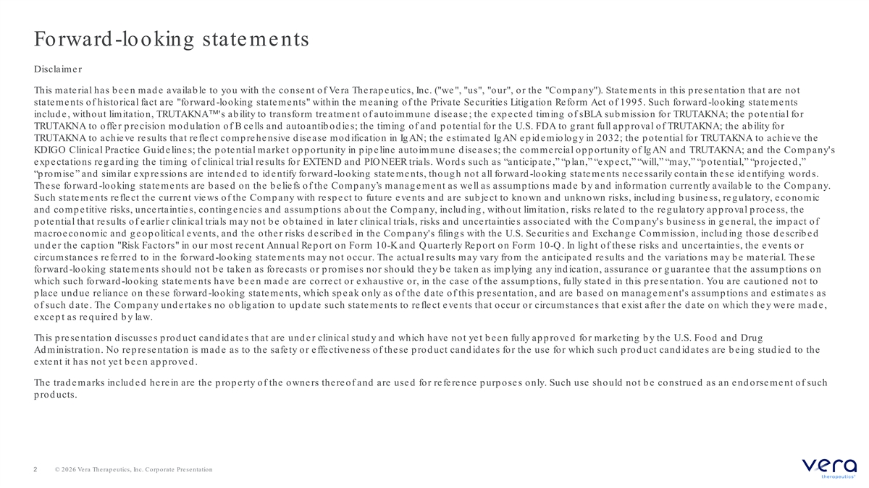
Forward -looking statements Disclaime r This material has b een mad e availab le to you with the consent of Vera Therap eutics, Inc. ( we , us , our , or the Comp any ). State me nts in this p re se ntation that are not state me nts of historical fact are forward -looking state me nts within the me aning of the Private Se curitie s Litig ation Re form Act of 1995. Such forward -looking state me nts includ e , without limitation, TRUTAKNA 's ab ility to transform tre atme nt of autoimmune d ise ase ; the e xp e cte d timing of sBLA sub mission for TRUTAKNA; the p ote ntial for TRUTAKNA to offe r p re cision mod ulation of B ce lls and autoantib od ie s; the timing of and p ote ntial for the U.S. FDA to g rant full ap p roval of TRUTAKNA; the ab ility for TRUTAKNA to achieve results that reflect comp rehensive d isease mod ification in Ig AN; the estimated Ig AN ep id emiolog y in 2032; the p otential for TRUTAKNA to achieve the KDIGO Clinical Practice Guid e line s; the p ote ntial marke t op p ortunity in p ip e line autoimmune d ise ase s; the comme rcial op p ortunity of Ig AN and TRUTAKNA; and the Comp any's e xp e ctations re g ard ing the timing of clinical trial re sults for EXTEND and PIO NEER trials. Word s such as “anticip ate ,” “p lan,” “e xp e ct,” “will,” “may,” “p ote ntial,” “p roje cte d ,” “p romise ” and similar e xp re ssions are inte nd e d to id e ntify forward -looking state me nts, though not all forward -looking state me nts ne ce ssarily co ntain the se id e ntifying wo rd s. The se fo rward -looking statements are b ased on the b eliefs of the Comp any’s manag ement as well as assump tions mad e b y and information curre ntly availab le to the Comp any. Such state me nts re fle ct the curre nt vie ws of the Comp any with re sp e ct to future e ve nts and are sub je ct to known and unknown risks, includ ing b usine ss, re g ulatory, e conomic and comp e titive risks, unce rtaintie s, conting e ncie s and assump tions ab out the Comp any, includ ing , without limitation, risks re late d to the re g ulatory ap p roval p roce ss, the p ote ntial that re sults of e arlie r clinical trials may not b e ob taine d in late r clinical trials, risks and unce rtaintie s associated with the Comp any's b usiness in g eneral, the imp act of macroe conomic and g e op olitical e ve nts, and the othe r risks d e scrib e d in the Comp any's filing s with the U.S. Se curitie s and Exchang e Commission, includ ing those d e scrib e d und e r the cap tion Risk Factors in our most re ce nt Annual Re p ort on Form 10-K and Q uarte rly Re p ort on Form 10-Q . In lig ht of these risks and uncertainties, the events or circumstance s re fe rre d to in the fo rward -looking state me nts may not occur. The actual re sults may vary from the anticip ate d re sults and the variations may b e mate rial. The se forward -looking state me nts should not b e take n as fore casts or p romise s nor should the y b e take n as imp lying any ind ication, assurance or g uarante e that the assump tions on which such forward -looking statements have b een mad e are correct or exhaustive or, in the case of the assump tions, fully stated in this p re se ntation. You are cautione d not to p lace und ue reliance on these forward -looking statements, which sp eak only as of the d ate of this p resentation, and are b ased on manag e me nt's assump tions and e stimate s as of such d ate . The Comp any und e rtake s no ob lig ation to up d ate such state me nts to re fle ct e ve nts that occur or circumstance s that exist after the d ate on which they were mad e, excep t as req uired b y law. This p re se ntation d iscusse s p rod uct cand id ate s that are und e r clinical stud y and which have not ye t b e e n fully ap p rove d for marke ting b y the U.S. Food and Drug Ad ministration. No rep resentation is mad e as to the safety or effectiveness of these p rod uct cand id ates for the use for which such p roduct candidate s are be ing studie d to the extent it has not yet b een ap p roved . The trad emarks includ ed herein are the p rop erty of the owners thereof and are used for reference p urp oses only. Such use should not b e construe d as an e nd orse me nt of such p rod ucts. 2 © 2026 Vera Therapeutics, Inc. Corporate Presentation

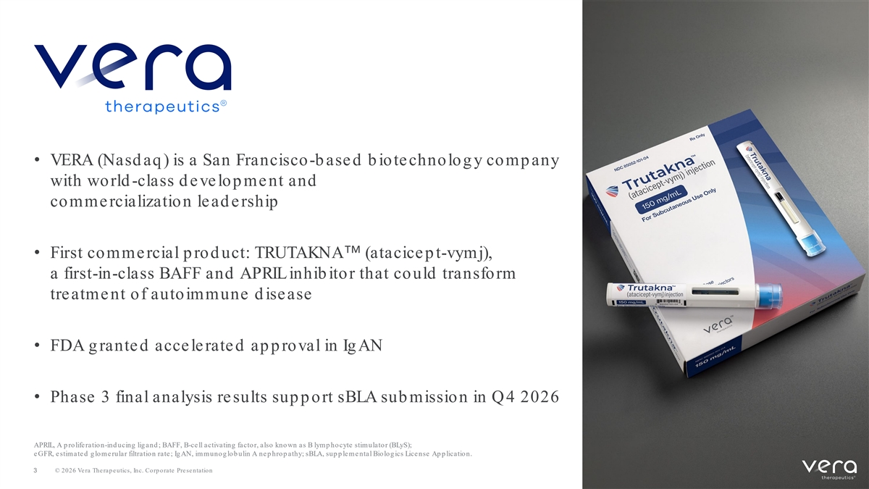
• VERA (Nasd aq ) is a San Francisco-b ased b iotechnolog y comp any with world -class d evelop ment and commercialization lead ership • First comme rcial p rod uct: TRUTAKNA (atacice p t-vymj), a first-in-class BAFF and APRIL inhib itor that could transform treatment of autoimmune d isease • FDA g rante d acce le rate d ap p roval in Ig AN • Phase 3 final analysis re sults sup p ort sBLA sub mission in Q4 2026 APRIL, A p roliferation-ind ucing lig and ; BAFF, B-ce ll activating facto r, also kno wn as B lymp ho cyte stimulato r (BLyS); e GFR, e stimate d g lo me rular filtratio n rate ; Ig AN, immuno g lo b ulin A ne p hro p athy; sBLA, sup p le me ntal Bio lo g ics Lice nse Ap p lication. 3 © 2026 Vera Therapeutics, Inc. Corporate Presentation

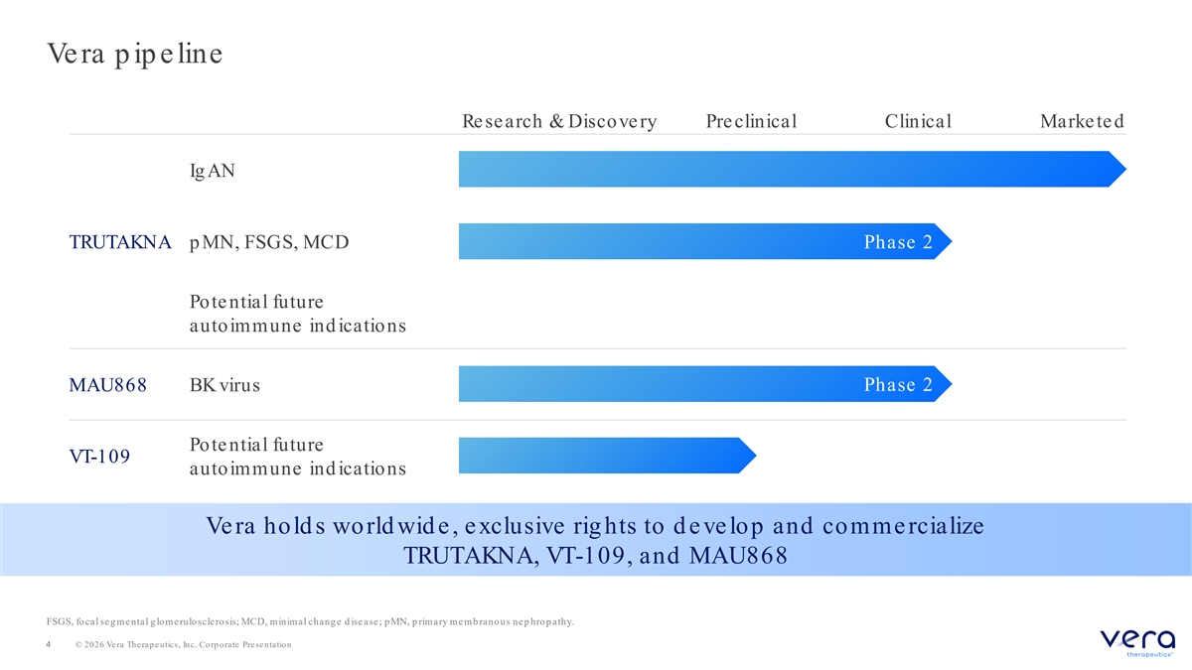
Ve ra p ip e line Re search & Discove ry Pre clinical Clinical Marke te d Ig AN TRUTAKNA p MN, FSGS, MCD Phase 2 Potential future autoimmune ind ications Phase 2 MAU868 BK virus Potential future VT-109 autoimmune ind ications Ve ra hold s world wid e , e xclusive rig hts to d e ve lop and comme rcialize TRUTAKNA, VT-109, and MAU868 FSGS, focal se g me ntal g lome ruloscle rosis; MCD, minimal chang e d ise ase ; p MN, p rimary me mb ranous ne p hrop athy. 4 © 2026 Vera Therapeutics, Inc. Corporate Presentation


Manag e me nt team: Succe ssful clinical and comme rcial track re cord Marshall Ford yce, MD Nancy Boman, MD, PhD Rob ert Brenner, MD Lauren Frenz, MBA Found e r and CEO Chie f Re g ulatory O ffice r Chie f Me d ical O ffice r Chie f Busine ss O ffice r Matt Ske lton Sean Grant, MBA David Johnson, MBA Jane Wrig ht-Mitche ll Chie f Financial O ffice r Chie f O p e rating O ffice r Chie f Comme rcial O ffice r Chie f Le g al O ffice r 5 © 2026 Vera Therapeutics, Inc. Corporate Presentation

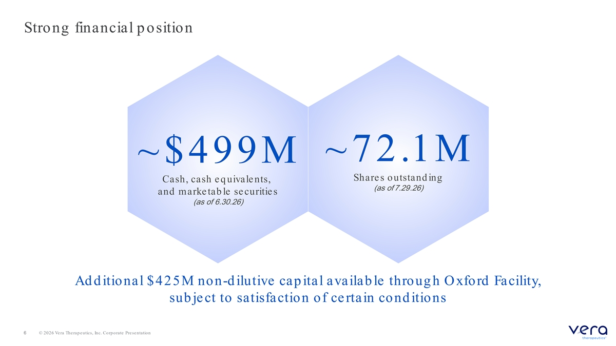
Strong financial p osition ~72.1M ~$499M Shares outstand ing Cash, cash e q uivale nts, (as of 7.29.26) and marketab le securities (as of 6.30.26) Ad d itional $425M non-d ilutive cap ital availab le throug h O xford Facility, sub je ct to satisfaction of ce rtain cond itions 6 © 2026 Vera Therapeutics, Inc. Corporate Presentation

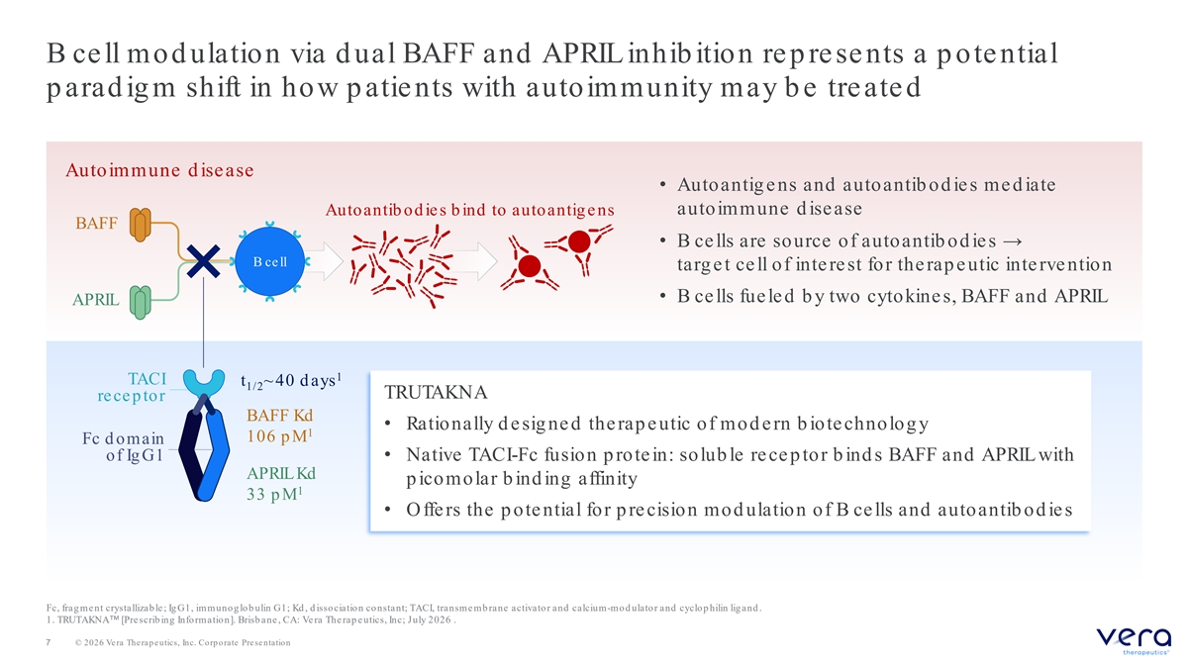
B ce ll mod ulation via d ual BAFF and APRIL inhib ition re p re se nts a p ote ntial p arad ig m shift in how p atie nts with autoimmunity may b e treate d Autoimmune d isease • Autoantigens and autoantib od ies med iate Autoantib od ie s b ind to autoantig e ns autoimmune d isease BAFF • B ce lls are source of autoantib od ie s → B ce ll targ et cell of interest for therap eutic intervention • B ce lls fue le d b y two cytokine s, BAFF and APRIL APRIL 1 TACI t ~ 40 d ays 1/2 TRUTAKNA recep tor BAFF Kd • Rationally d esig ned therap eutic of mod ern b iotechnolog y 1 106 p M Fc d omain of Ig G1 • Native TACI-Fc fusion p rote in: solub le re ce p tor b ind s BAFF and APRIL with APRIL Kd p icomolar b ind ing affinity 1 33 p M • Offers the p otential for p recision mod ulation of B cells and autoantib od ies Fc, frag me nt crystallizab le ; Ig G1, immunog lob ulin G1; Kd , d isso ciatio n co nstant; TACI, transme mb rane activato r and calcium-m o d ulato r and cyclo p hilin lig and . 1. TRUTAKNA [Pre scrib ing Information]. Brisb ane , CA: Ve ra The rap e utics, Inc; July 2026 . 7 © 2026 Vera Therapeutics, Inc. Corporate Presentation

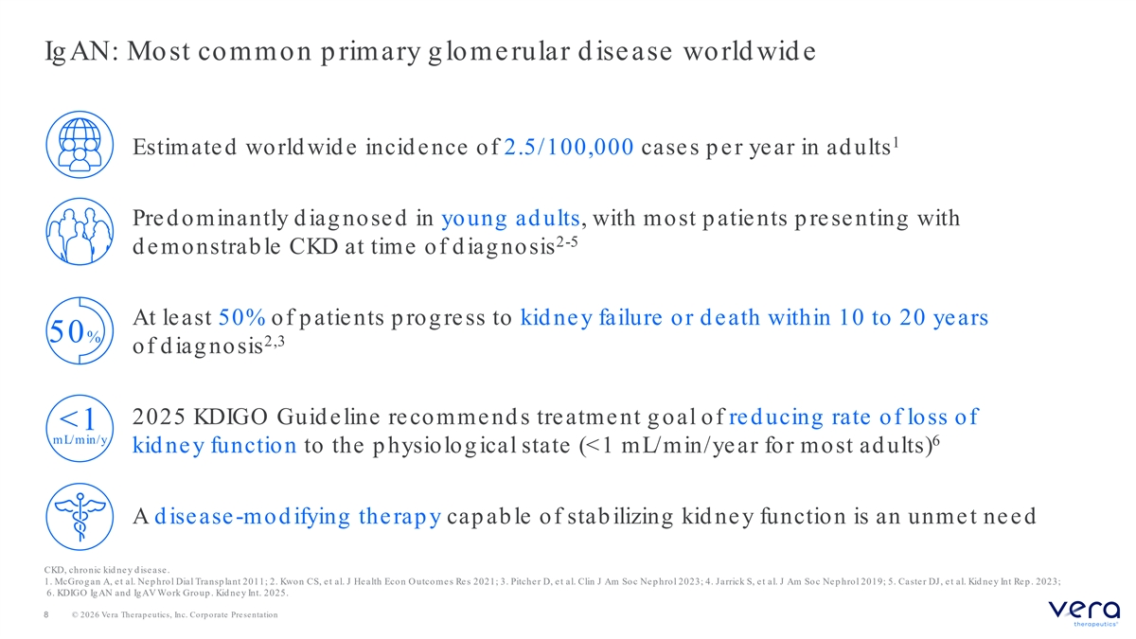
Ig AN: Most common p rimary g lome rular d isease world wid e 1 Estimate d world wid e incid e nce of 2.5/100,000 cases p er year in ad ults Pre d ominantly d iag nose d in young ad ults, with most p atie nts p re se nting with 2-5 d e monstrab le CKD at time of d iag nosis At least 50% of p atients p rog ress to kid ney failure or d eath within 10 to 20 years 50 % 2,3 of d iag nosis 2025 KDIGO Guid e line re comme nd s treatme nt g oal of red ucing rate of loss of <1 mL/min/y 6 kid ney function to the p hysiolog ical state (<1 mL/min/year for most ad ults) A d isease -modifying the rapy cap ab le of stab ilizing kid ney function is an unmet need CKD, chro nic kid ne y d ise ase . 1. McGrog an A, e t al. Ne p hrol Dial Transp lant 2011; 2. Kwon CS, e t al. J He alth Econ O utcome s Re s 2021; 3. Pitche r D, e t al. Clin J Am Soc Nep hrol 2023; 4. Jarrick S, et al. J Am Soc Nep hrol 2019; 5. Caster DJ, et al. Kid ney Int Rep . 2023; 6. KDIGO IgAN and Ig AV Work Group . Kid ne y Int. 2025. 8 © 2026 Vera Therapeutics, Inc. Corporate Presentation

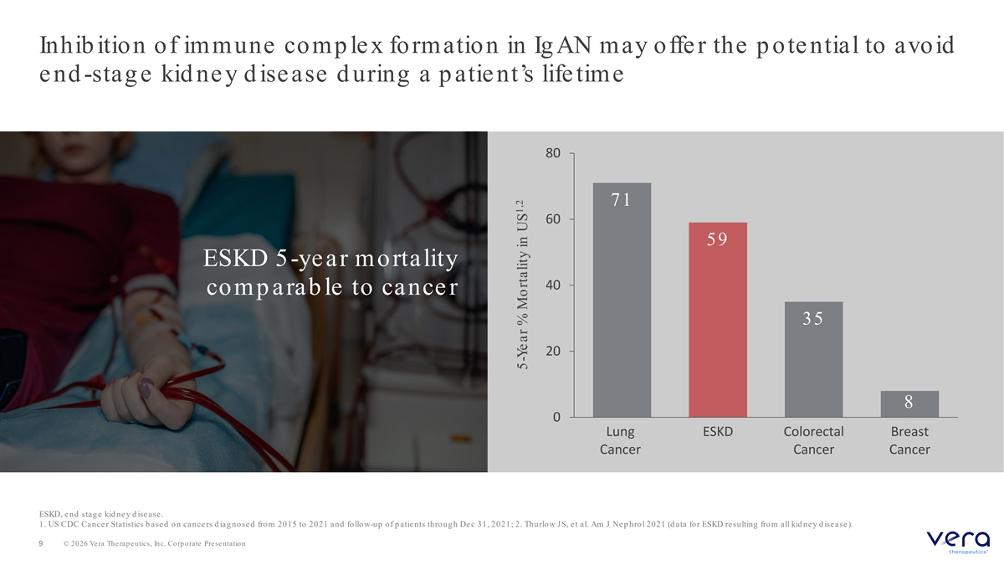
Inhib ition of immune comp lex formation in Ig AN may offe r the p ote ntial to avoid e nd -stag e kid ney d isease d uring a p atient’s lifetime 80 71 60 59 ESKD 5-year mortality 40 comp arab le to cance r 35 20 8 0 Lung ESKD Colorectal Breast Cancer Cancer Cancer ESKD, end stag e kid ney d isease. 1. US CDC Cance r Statistics b ase d on cance rs d iag nose d from 2015 to 2021 and fo llo w-up of p atie nts throug h De c 31, 2021; 2. Thurlow JS, et al. Am J Nep hrol 2021 (d ata for ESKD resulting from all kid ney d isease). 9 © 2026 Vera Therapeutics, Inc. Corporate Presentation 1,2 5-Ye ar % Mortality in US

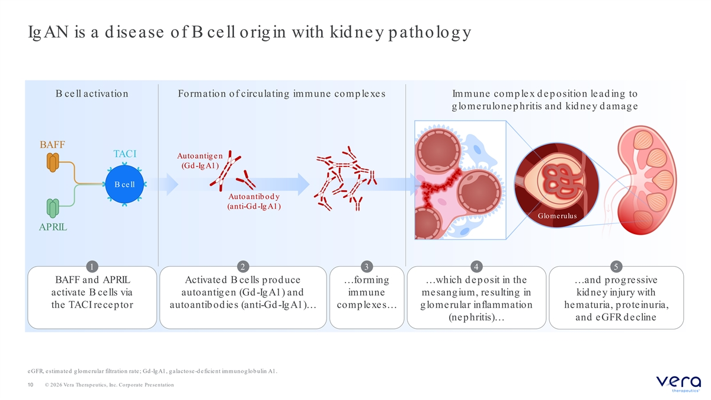
Ig AN is a d isease of B ce ll orig in with kid ne y p atholog y B ce ll activation Formation of circulating immune comp le xe s Immune comp le x d e p osition le ad ing to g lome rulone p hritis and kid ne y d amag e BAFF TACI Autoantig e n (Gd -Ig A1) B ce ll Autoantib od y (anti-Gd -Ig A1) Glomerulus APRIL 1 2 3 4 5 BAFF and APRIL Activated B cells prod uce …forming …which d eposit in the …and progressive activate B cells via autoantigen (Gd-IgA1) and immune mesangium, resulting in kid ney injury with the TACI receptor autoantibodies (anti-Gd-IgA1)… complexes… glomerular inflammation hematuria, proteinuria, (nephritis)… and eGFR d ecline e GFR, e stimate d g lome rular filtration rate ; Gd -IgA1, galactose-d e ficie nt im m uno g lo b ulin A1. 10 © 2026 Vera Therapeutics, Inc. Corporate Presentation

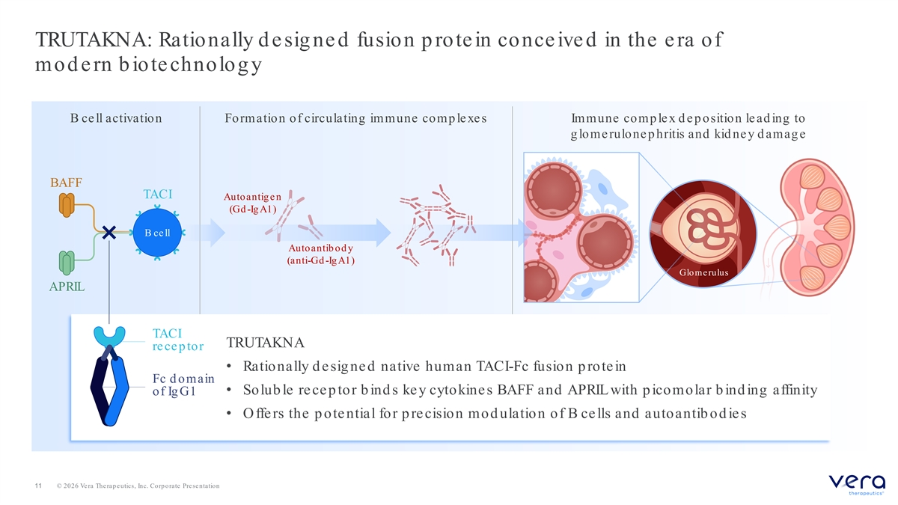
TRUTAKNA: Rationally d e sig ne d fusion p rote in conce ive d in the e ra of mod e rn b iote chnolog y B ce ll activation Formation of circulating immune comp le xe s Immune comp le x d e p osition le ad ing to g lome rulone p hritis and kid ne y d amag e BAFF TACI Autoantig e n (Gd -Ig A1) B ce ll Autoantib od y (anti-Gd -Ig A1) Glomerulus APRIL TACI TRUTAKNA recep tor • Rationally d e sig ne d native human TACI-Fc fusion p rote in Fc d omain • Solub le recep tor b ind s key cytokines BAFF and APRIL with p icomolar b ind ing affinity of Ig G1 • Offers the p otential for p recision mod ulation of B cells and autoantib od ies 11 © 2026 Vera Therapeutics, Inc. Corporate Presentation

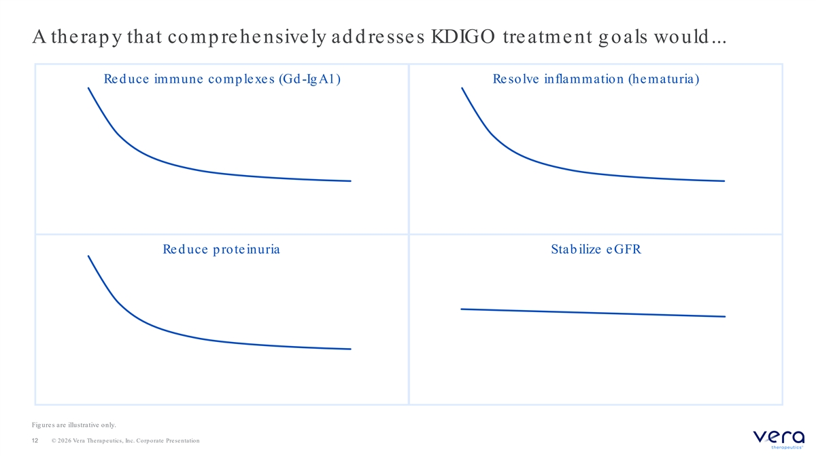
A therap y that comp rehensively ad d resses KDIGO treatment g oals would ... Red uce immune comp lexes (Gd -Ig A1) Resolve inflammation (hematuria) Red uce p roteinuria Stab ilize eGFR Fig ure s are illustrative o nly. 12 © 2026 Vera Therapeutics, Inc. Corporate Presentation

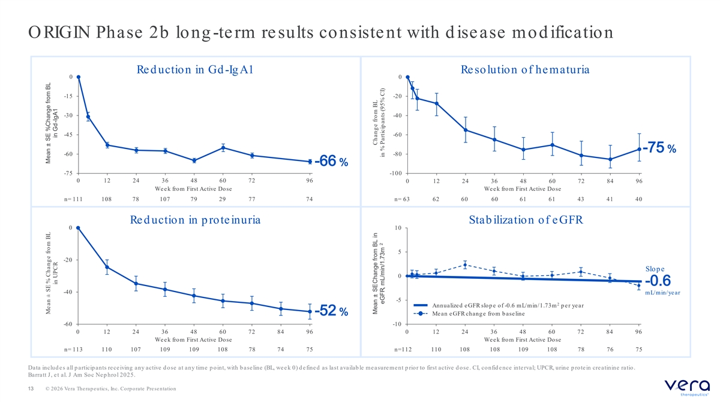
O RIGIN Phase 2b long -te rm re sults consiste nt with d isease mod ification Red uction in Gd -Ig A1 Resolution of hematuria 0 0 -15 -20 -30 -40 -45 -60 -75 % -60 -80 -66 % -75 -100 0 12 24 36 48 60 72 96 0 12 24 36 48 60 72 84 96 Week from First Active Dose We e k from First Active Dose n= 111 108 78 107 79 29 77 74 n= 63 62 60 60 61 61 43 41 40 Red uction in p roteinuria Stab ilization of eGFR 0 10 5 -20 Slop e 0 -0.6 -40 mL/min/year -5 2 Annualize d e GFR slo p e o f -0.6 mL/min/1.73m p er year -52 % Me an e GFR chang e from b ase line -60 -10 0 12 24 36 48 60 72 84 96 0 12 24 36 48 60 72 84 96 We e k from First Active Dose We e k from First Active Dose n= 113 110 107 109 109 108 78 74 75 n=112 110 108 108 109 108 78 76 75 Data includ e s all p articip ants re ce iving any active d ose at any time p oint, with b ase line (BL, we e k 0) d e fine d as last availab le measurement p rior to first active d ose. CI, confid ence interval; UPCR, urine p rotein creatinine ratio. Barratt J, et al. J Am Soc Nep hrol 2025. 13 © 2026 Vera Therapeutics, Inc. Corporate Presentation Mean ± SE % Chang e from BL Mean ± SE % Change from BL in UPCR in Gd-IgA1 Mean ± SE Change from BL in Chang e fro m BL 2 eGFR, mL/min/1.73m in % Particip ants (95% CI)

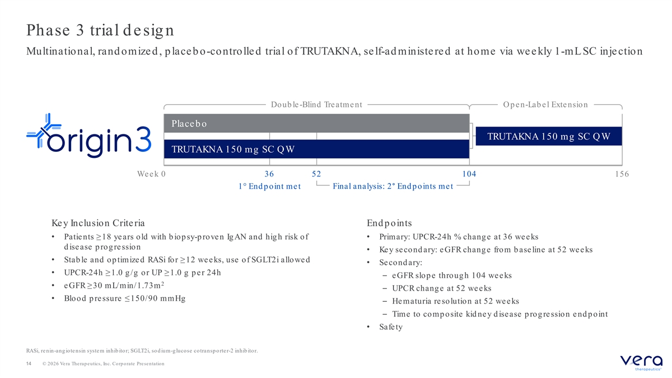
Phase 3 trial d e sig n Multinational, rand omize d , p lace b o-controlle d trial of TRUTAKNA, se lf-ad ministe re d at home via we e kly 1-mL SC inje ction Doub le -Blind Tre atme nt O p en-Lab el Extension Place b o TRUTAKNA 150 mg SC Q W TRUTAKNA 150 mg SC Q W Week 0 36 52 104 156 1° End point met Final analysis: 2° End points met Ke y Inclusion Crite ria End p oints • Patie nts ≥18 ye ars old with b iop sy-p rove n Ig AN and hig h risk of • Primary: UPCR-24h % change at 36 weeks d isease progression • Key second ary: eGFR change from b aseline at 52 weeks • Stab le and op timize d RASi for ≥12 we e ks, use of SGLT2i allowe d • Se cond ary: • UPCR-24h ≥1.0 g /g or UP ≥1.0 g p e r 24h – eGFR slope through 104 weeks 2 • e GFR ≥30 mL/min/1.73m – UPCR chang e at 52 we e ks • Blood p re ssure ≤150/90 mmHg – Hematuria resolution at 52 weeks – Time to comp osite kid ne y d isease p rog re ssion e nd p oint • Safe ty RASi, re nin-ang io te nsin syste m inhib ito r; SGLT2i, so d ium-g lucose co transp o rte r-2 inhib ito r. 14 © 2026 Vera Therapeutics, Inc. Corporate Presentation

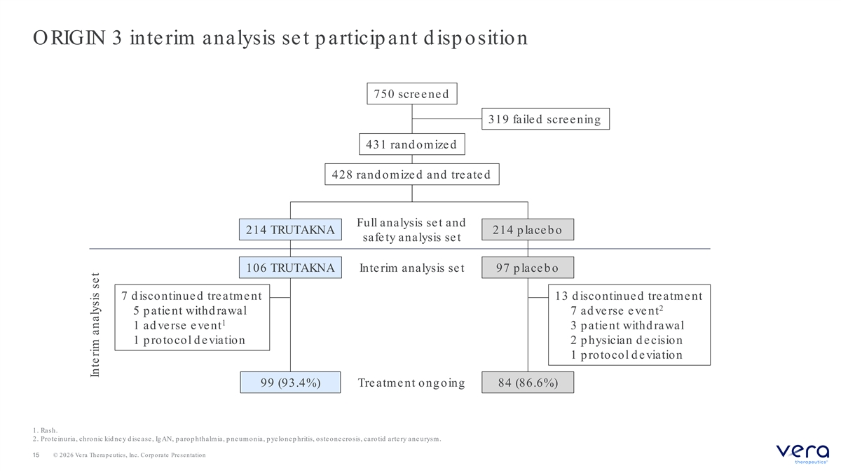
O RIGIN 3 inte rim analysis se t p articip ant d isp osition 750 scre e ne d 319 faile d scre e ning 431 rand omize d 428 rand omize d and tre ate d Full analysis se t and 214 TRUTAKNA 214 p lace b o safe ty analysis se t 106 TRUTAKNA Inte rim analysis se t 97 p lace b o 7 d iscontinue d tre atme nt 13 d iscontinue d tre atme nt 2 5 p atie nt withd rawal 7 ad verse event 1 1 ad verse event 3 p atie nt withd rawal 1 p rotocol d e viation 2 p hysician d e cision 1 p rotocol d e viation 99 (93.4%) Tre atme nt ong oing 84 (86.6%) 1. Rash. 2. Prote inuria, chronic kid ne y d ise ase , Ig AN, p arop hthalmia, p ne umo nia, p ye lo ne p hritis, oste one cro sis, caro tid arte ry ane urysm. 15 © 2026 Vera Therapeutics, Inc. Corporate Presentation Inte rim analysis se t

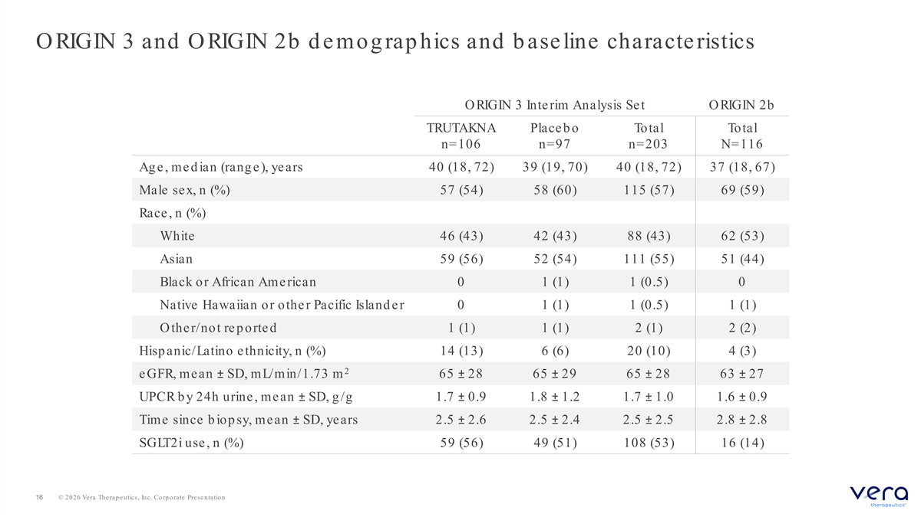
O RIGIN 3 and O RIGIN 2b d e mog rap hics and b ase line characte ristics ORIGIN 3 Inte rim Analysis Se t ORIGIN 2b TRUTAKNA Place b o Total Total n=106 n=97 n=203 N=116 Ag e, med ian (rang e), years 40 (18, 72) 39 (19, 70) 40 (18, 72) 37 (18, 67) Male sex, n (%) 57 (54) 58 (60) 115 (57) 69 (59) Race , n (%) White 46 (43) 42 (43) 88 (43) 62 (53) Asian 59 (56) 52 (54) 111 (55) 51 (44) Black or African Ame rican 0 1 (1) 1 (0.5) 0 Native Hawaiian or othe r Pacific Island e r 0 1 (1) 1 (0.5) 1 (1) O the r/not re p orte d 1 (1) 1 (1) 2 (1) 2 (2) Hisp anic/Latino e thnicity, n (%) 14 (13) 6 (6) 20 (10) 4 (3) 2 e GFR, me an ± SD, mL/min/1.73 m 65 ± 28 65 ± 29 65 ± 28 63 ± 27 UPCR b y 24h urine , me an ± SD, g /g 1.7 ± 0.9 1.8 ± 1.2 1.7 ± 1.0 1.6 ± 0.9 Time since b iop sy, me an ± SD, ye ars 2.5 ± 2.6 2.5 ± 2.4 2.5 ± 2.5 2.8 ± 2.8 SGLT2i use , n (%) 59 (56) 49 (51) 108 (53) 16 (14) 16 © 2026 Vera Therapeutics, Inc. Corporate Presentation

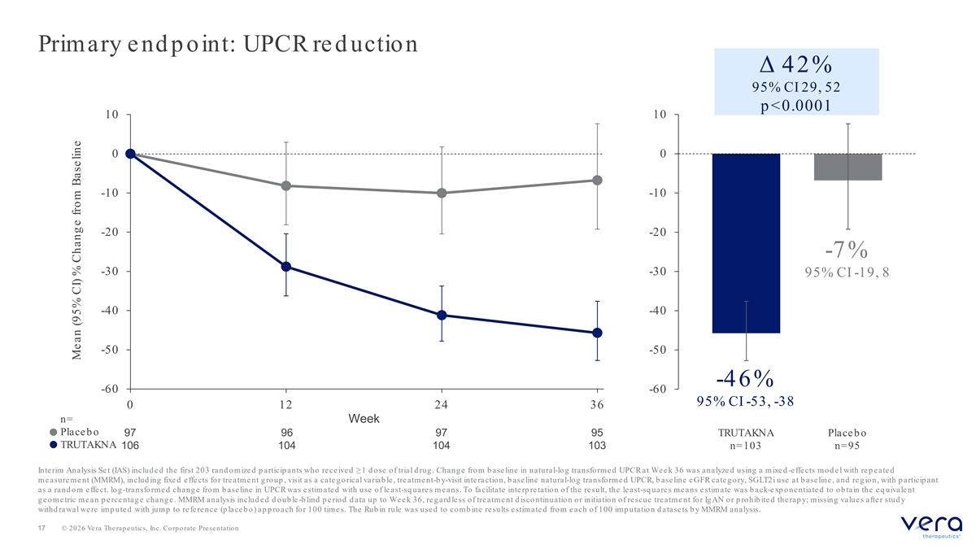
Primary e nd p oint: UPCR re d uction Δ 42% 95% CI 29, 52 p <0.0001 10 10 0 0 -10 -10 -20 -20 -7% -30 -30 95% CI -19, 8 -40 -40 -50 -50 -46% -60 -60 95% CI -53, -38 0 12 24 36 n= Week Placeb o 97 96 97 95 TRUTAKNA Placeb o TRUTAKNA 106 104 104 103 n=103 n=95 Interim Analysis Set (IAS) includ ed the first 203 rand omized p articip ants who received ≥1 d ose of trial d rug . Chang e from b as eline in natural-lo g transfo rme d UPCR at We e k 36 was analyze d using a mixe d -effects mod el with rep eated measurement (MMRM), includ ing fixed effects for treatment g roup , visit as a categ orical variab le, treatment-by-visit inte ractio n, b ase line natural-log transforme d UPCR, b ase line e GFR cate g ory, SGLT2i use at b ase line , and re g ion, with p articip ant as a rand om e ffe ct. log -transformed chang e from b aseline in UPCR was estimated with use of least-sq uare s me ans. To facilitate inte rp re tation of the re sult, the le ast-sq uare s me ans e stimate was b ack-e xp o ne ntiate d to o b tain the e q uivale nt g e ome tric me an p e rce ntag e chang e . MMRM analysis includ e d d oub le-blind pe riod data up to We e k 36, re g ardle ss of tre atme nt discontinuation or initiation of re scue tre atme nt for Ig AN or p rohib ite d the rap y; missing value s afte r stud y withd rawal we re imp ute d with jump to re fe re nce (p lace b o) ap p roach for 100 time s. The Rub in rule was use d to comb ine re sults estimate d from e ach of 100 imp utation d atase ts b y MMRM analysis. 17 © 2026 Vera Therapeutics, Inc. Corporate Presentation Mean (95% CI) % Chang e from Baseline

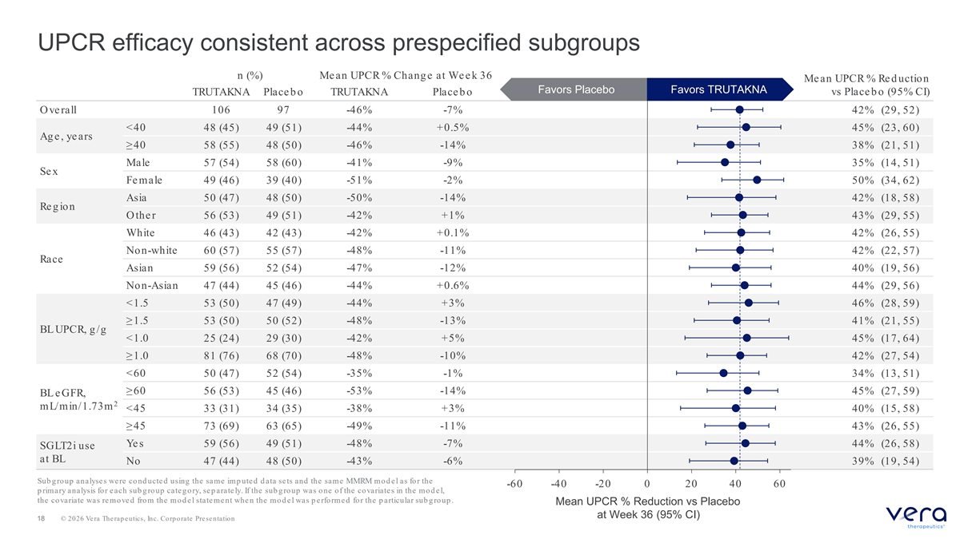
UPCR efficacy consistent across prespecified subgroups n (%) Mean UPCR % Chang e at Week 36 Me an UPCR % Re d uction Favors Placebo Favors TRUTAKNA vs Place b o (95% CI) TRUTAKNA Place b o TRUTAKNA Place b o O ve rall 106 97 -46% -7% 42% (29, 52) <40 48 (45) 49 (51) -44% +0.5% 45% (23, 60) Ag e, years ≥40 58 (55) 48 (50) -46% -14% 38% (21, 51) Male 57 (54) 58 (60) -41% -9% 35% (14, 51) Se x Fe male 49 (46) 39 (40) -51% -2% 50% (34, 62) Asia 50 (47) 48 (50) -50% -14% 42% (18, 58) Re g ion O the r 56 (53) 49 (51) -42% +1% 43% (29, 55) White 46 (43) 42 (43) -42% +0.1% 42% (26, 55) Non-white -48% -11% 60 (57) 55 (57) 42% (22, 57) Race Asian 59 (56) 52 (54) -47% -12% 40% (19, 56) Non-Asian 47 (44) 45 (46) -44% +0.6% 44% (29, 56) <1.5 53 (50) 47 (49) -44% +3% 46% (28, 59) ≥1.5 53 (50) 50 (52) -48% -13% 41% (21, 55) BL UPCR, g /g <1.0 25 (24) 29 (30) -42% +5% 45% (17, 64) ≥1.0 81 (76) 68 (70) -48% -10% 42% (27, 54) <60 50 (47) 52 (54) -35% -1% 34% (13, 51) ≥60 56 (53) 45 (46) -53% -14% 45% (27, 59) BL e GFR, 2 mL/min/1.73m <45 33 (31) 34 (35) -38% +3% 40% (15, 58) ≥45 73 (69) 63 (65) -49% -11% 43% (26, 55) Ye s 59 (56) 49 (51) -48% -7% 44% (26, 58) SGLT2i use at BL No -43% -6% 47 (44) 48 (50) 39% (19, 54) Sub g roup analyse s we re cond ucte d using the same imp ute d d ata se ts and the same MMRM mod e l as for the -60 -40 -20 0 20 40 60 p rimary analysis for e ach sub g roup cate g ory, se p arate ly. If the sub g roup was one of the covariate s in the mod e l, the covariate was removed from the mod el statement when the mod el was p erformed for the p articular sub g roup . Mean UPCR % Reduction vs Placebo at Week 36 (95% CI) 18 © 2026 Vera Therapeutics, Inc. Corporate Presentation

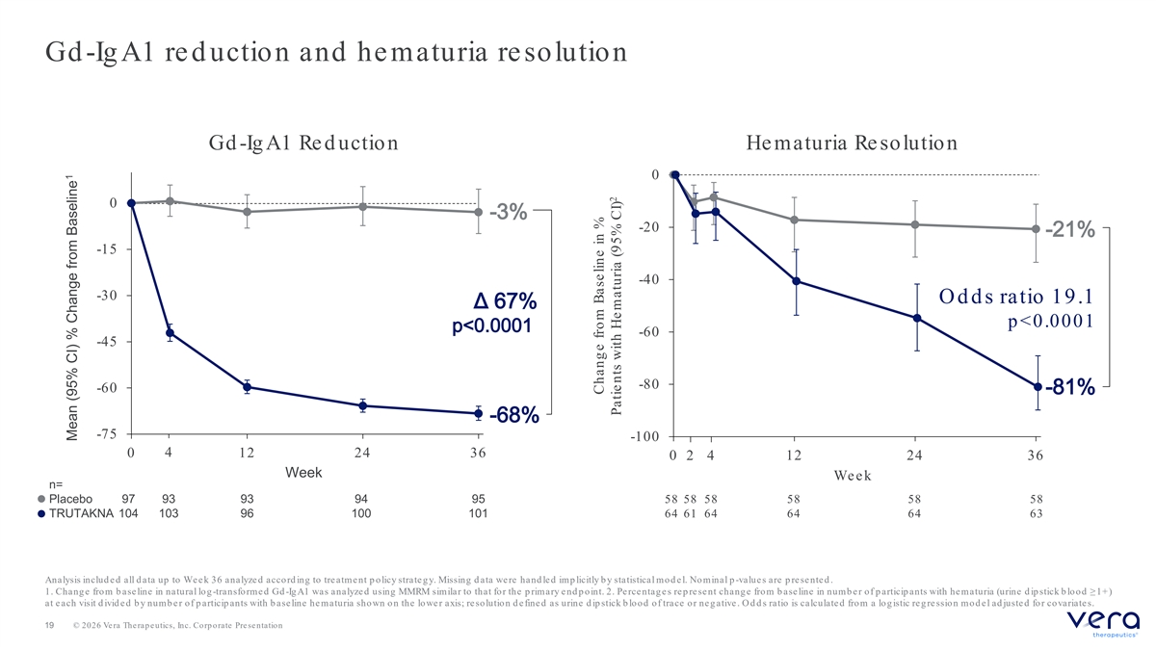
Gd -Ig A1 re d uction and he maturia re solution Gd -Ig A1 Re d uction He maturia Re solution 0 0 -3% -20 -21% -15 -40 -30 O d d s ratio 19.1 Δ 67% p <0.0001 p<0.0001 -60 -45 -80 -60 -81% -68% -75 -100 0 4 12 24 36 0 2 4 12 24 36 Week Week n= Placebo 97 93 93 94 95 58 58 58 58 58 58 TRUTAKNA 104 103 96 100 101 64 61 64 64 64 63 Analysis includ e d all d ata up to We e k 36 analyze d acco rd ing to tre atme nt p o licy strate g y. Missing d ata we re hand le d imp licitly b y statistical m o d e l. No m inal p -values are p resented . 1. Chang e from b ase line in natural log -transfo rme d Gd -Ig A1 was analyze d using MMRM similar to that for the p rimary e nd p o int. 2. Percentag es rep resent chang e from b aseline in numb er of p articip ants with hematuria (urine d ip stick b lood ≥1+) at e ach visit d ivid e d b y numb e r of p articip ants with b ase line he maturia shown on the lo we r axis; re solutio n d e fine d as urine d ip stick b lood of trace or ne g ative . O d d s ratio is calculate d from a log istic re g re ssion mod e l ad juste d for covariate s. 19 © 2026 Vera Therapeutics, Inc. Corporate Presentation 1 Mean (95% CI) % Change from Baseline Change from Baseline in % 2 Patie nts with He maturia (95% CI)

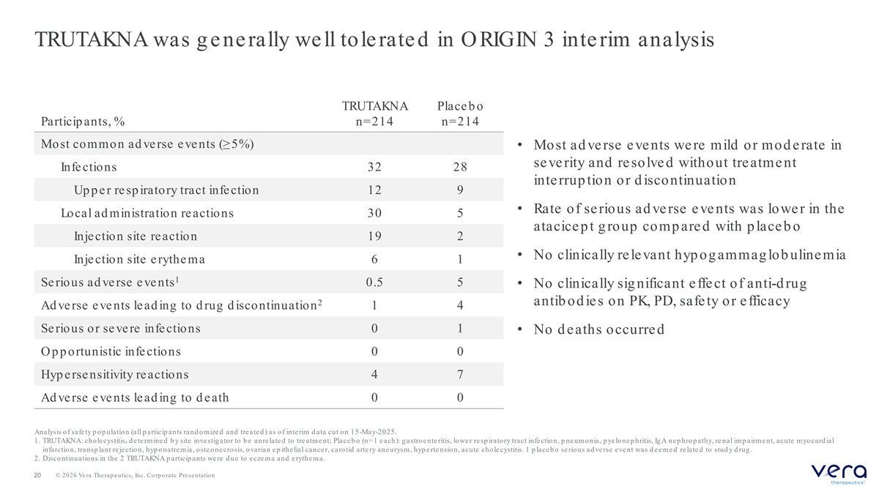
TRUTAKNA was g e ne rally we ll tole rate d in O RIGIN 3 inte rim analysis TRUTAKNA Place b o Particip ants, % n=214 n=214 Most common ad ve rse e ve nts (≥5%) • Most ad verse events were mild or mod erate in severity and resolved without treatment Infe ctions 32 28 interrup tion or d iscontinuation Up p e r re sp iratory tract infe ction 12 9 • Rate of serious ad verse events was lower in the Local ad ministration re actions 30 5 atacicept group compared with placeb o Inje ction site re action 19 2 • No clinically re le vant hyp og ammag lob uline mia Injection site erythema 6 1 1 Serious ad verse events 0.5 5 • No clinically sig nificant effect of anti-d rug 2 antib od ie s on PK, PD, safe ty or e fficacy Ad ve rse e ve nts le ad ing to d rug d iscontinuation 1 4 Serious or severe infections 0 1 • No d eaths occurred O p p ortunistic infe ctions 0 0 Hyp e rse nsitivity re actions 4 7 Ad verse events le ad ing to d e ath 0 0 Analysis of safe ty p op ulation (all p articip ants rand omize d and tre ate d ) as of inte rim d ata cut on 15-May-2025. 1. TRUTAKNA: cho le cystitis, d e te rmine d b y site inve stig ator to b e unre late d to tre atme nt; Place b o (n=1 e ach): g astroe nte ritis, lowe r re sp iratory tract infe ction, p ne umonia, p ye lone p hritis, Ig A ne p hrop athy, re nal imp airme nt, acute myocard ial infarctio n, transp lant re je ctio n, hyp o natre mia, o ste o ne cro sis, o varian e p ithe lial cance r, caro tid arte ry ane urysm, hyp e rte nsion, acute cholecystitis. 1 p laceb o serious ad verse event was d eemed related to stud y d rug . 2. Discontinuations in the 2 TRUTAKNA p articip ants we re d ue to e cze ma and e rythe ma. 20 © 2026 Vera Therapeutics, Inc. Corporate Presentation

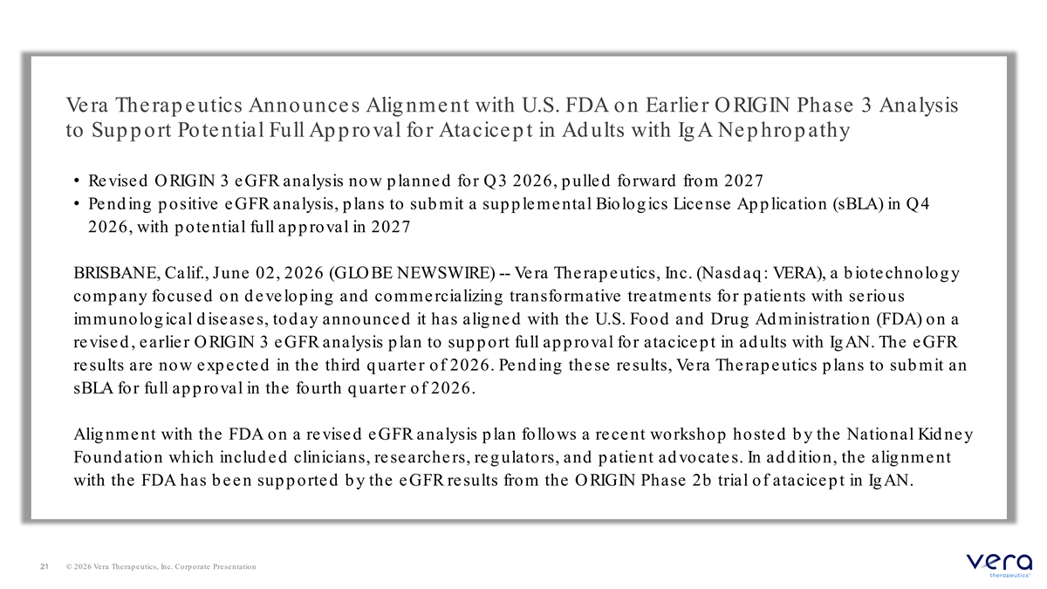
Ve ra The rap e utics Announce s Alig nme nt with U.S. FDA on Earlie r O RIGIN Phase 3 Analysis to Sup p ort Potential Full Ap p roval for Atacicep t in Ad ults with Ig A Nep hrop athy • Re vise d O RIGIN 3 e GFR analysis now p lanne d for Q3 2026, p ulle d forward from 2027 • Pe nd ing p ositive e GFR analysis, p lans to sub mit a sup p le me ntal Biolog ics Lice nse Ap p lication (sBLA) in Q4 2026, with p ote ntial full ap p roval in 2027 BRISBANE, Calif., June 02, 2026 (GLO BE NEWSWIRE) -- Ve ra The rap e utics, Inc. (Nasd aq : VERA), a b iote chnolog y comp any focused on d evelop ing and commercializing transformative treatments for p atients with serious immunolog ical d isease s, tod ay announce d it has alig ne d with the U.S. Food and Drug Ad ministration (FDA) on a re vise d , earlie r O RIGIN 3 e GFR analysis p lan to sup p ort full ap p roval for atacice p t in ad ults with Ig AN. The e GFR results are now exp ected in the third q uarter of 2026. Pend ing these results, Vera Therap eutics p lans to sub mit an sBLA for full ap p roval in the fourth q uarter of 2026. Alig nme nt with the FDA on a re vise d e GFR analysis p lan follows a re ce nt workshop hoste d b y the National Kid ne y Found ation which includ e d clinicians, re searche rs, re g ulators, and p atie nt ad vocate s. In ad d ition, the alig nme nt with the FDA has b een sup p orted b y the eGFR results from the ORIGIN Phase 2b trial of atacicep t in Ig AN. 21 © 2026 Vera Therapeutics, Inc. Corporate Presentation

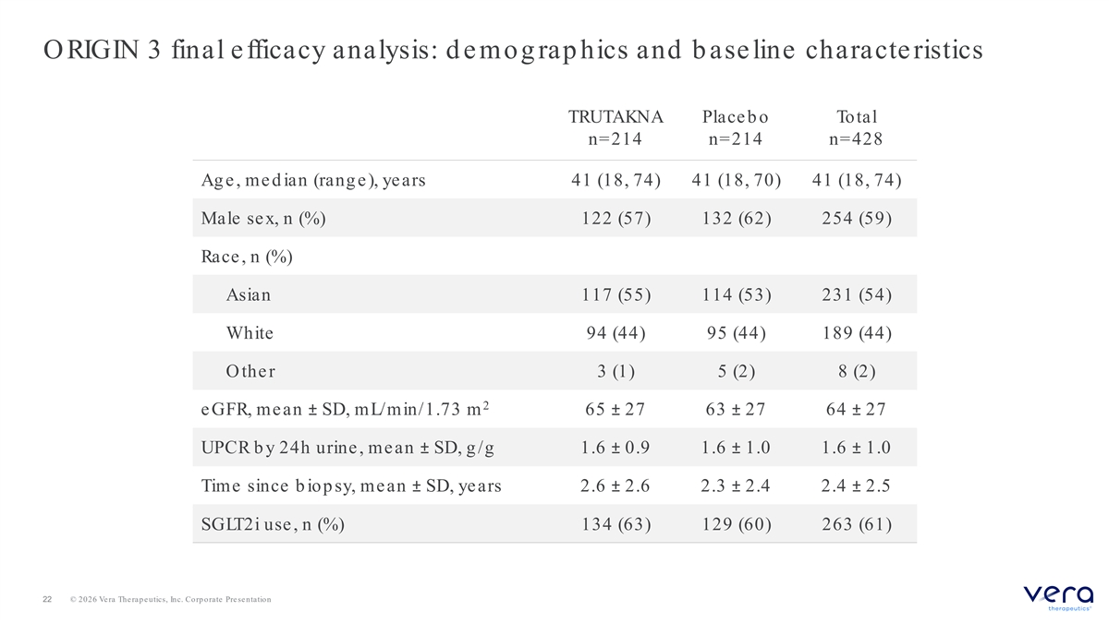
O RIGIN 3 final efficacy analysis: d emog rap hics and b aseline characteristics TRUTAKNA Place b o Total n=214 n=214 n=428 Ag e, med ian (rang e), years 41 (18, 74) 41 (18, 70) 41 (18, 74) Male sex, n (%) 122 (57) 132 (62) 254 (59) Race , n (%) Asian 117 (55) 114 (53) 231 (54) White 94 (44) 95 (44) 189 (44) O the r 3 (1) 5 (2) 8 (2) 2 e GFR, mean ± SD, mL/min/1.73 m 65 ± 27 63 ± 27 64 ± 27 UPCR b y 24h urine , mean ± SD, g /g 1.6 ± 0.9 1.6 ± 1.0 1.6 ± 1.0 Time since b iop sy, mean ± SD, years 2.6 ± 2.6 2.3 ± 2.4 2.4 ± 2.5 SGLT2i use , n (%) 134 (63) 129 (60) 263 (61) 22 © 2026 Vera Therapeutics, Inc. Corporate Presentation

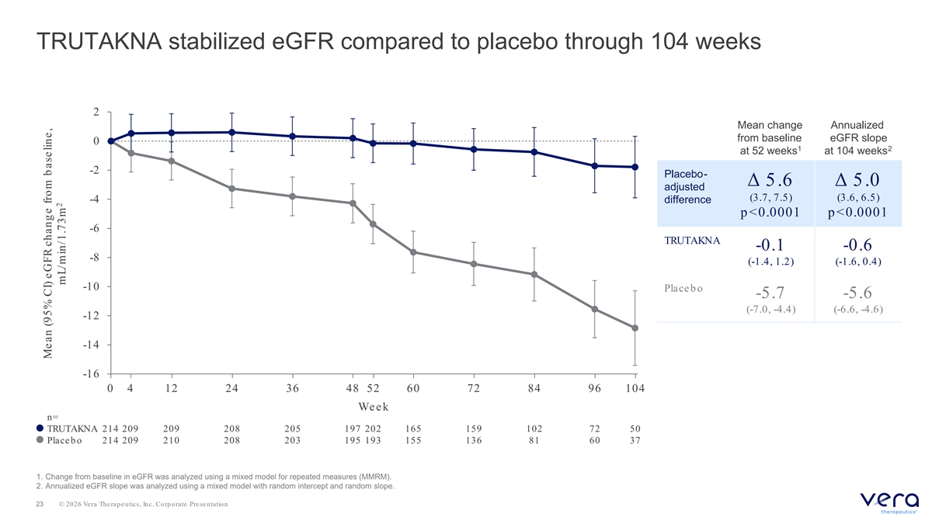
TRUTAKNA stabilized eGFR compared to placebo through 104 weeks 2 Mean change Annualized from baseline eGFR slope 0 1 2 at 52 weeks at 104 weeks -2 Placebo- Δ 5.6 Δ 5.0 adjusted (3.7, 7.5) (3.6, 6.5) -4 difference p <0.0001 p <0.0001 -6 TRUTAKNA -0.1 -0.6 -8 (-1.4, 1.2) (-1.6, 0.4) -10 Place b o -5.7 -5.6 (-7.0, -4.4) (-6.6, -4.6) -12 -14 -16 0 4 12 24 36 48 52 60 72 84 96 104 Week n= TRUTAKNA 214 209 209 208 205 197 202 165 159 102 72 50 Placeb o 214 209 210 208 203 195 193 155 136 81 60 37 1. Change from baseline in eGFR was analyzed using a mixed model for repeated measures (MMRM). 2. Annualized eGFR slope was analyzed using a mixed model with random intercept and random slope. 23 © 2026 Vera Therapeutics, Inc. Corporate Presentation Mean (95% CI) eGFR chang e from b aseline, 2 mL/min/1.73m

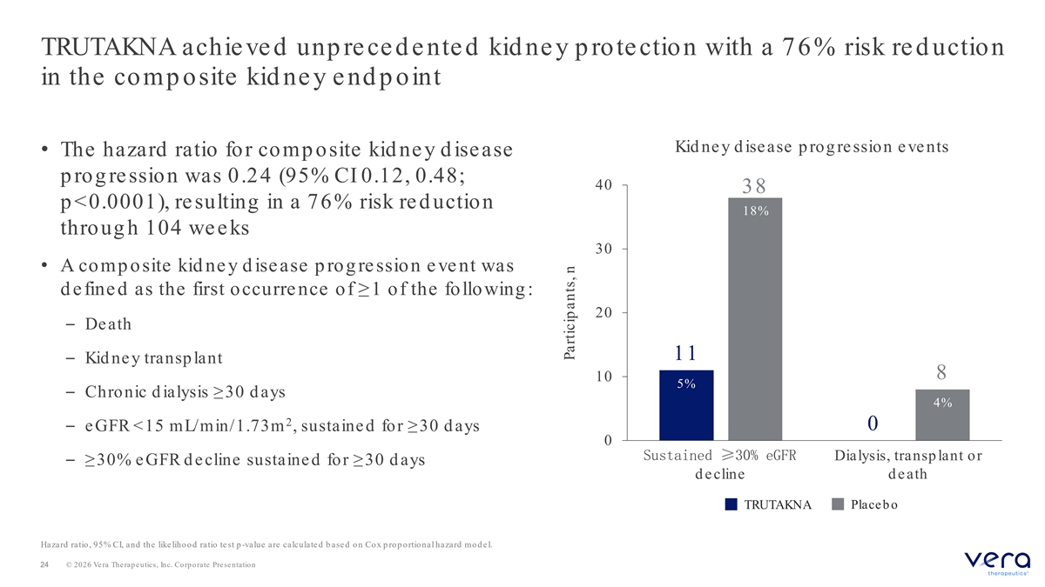
TRUTAKNA achieved unp reced ented kid ney p rotection with a 76% risk re d uction in the comp osite kid ney end p oint Kid ney d isease p rog ression events • The hazard ratio for comp osite kid ne y d isease p rog re ssion was 0.24 (95% CI 0.12, 0.48; 40 38 p <0.0001), re sulting in a 76% risk red uction 18% throug h 104 we e ks 30 • A comp osite kid ne y d ise ase p rog re ssion e ve nt was d e fine d as the first occurre nce of ≥1 of the following : 20 – Death 11 – Kid ne y transp lant 8 10 5% – Chronic d ialysis ≥30 d ays 4% 2 0 – e GFR <15 mL/min/1.73m , sustaine d for ≥30 d ays 0 Sustained ≥30% eGFR Dialysis, transp lant or – ≥30% e GFR d e cline sustaine d for ≥30 d ays d e cline d e ath TRUTAKNA Place b o Hazard ratio, 95% CI, and the like lihood ratio te st p -value are calculate d b ase d o n Co x p ro p o rtio nal hazard mo d e l. 24 © 2026 Vera Therapeutics, Inc. Corporate Presentation Particip ants, n

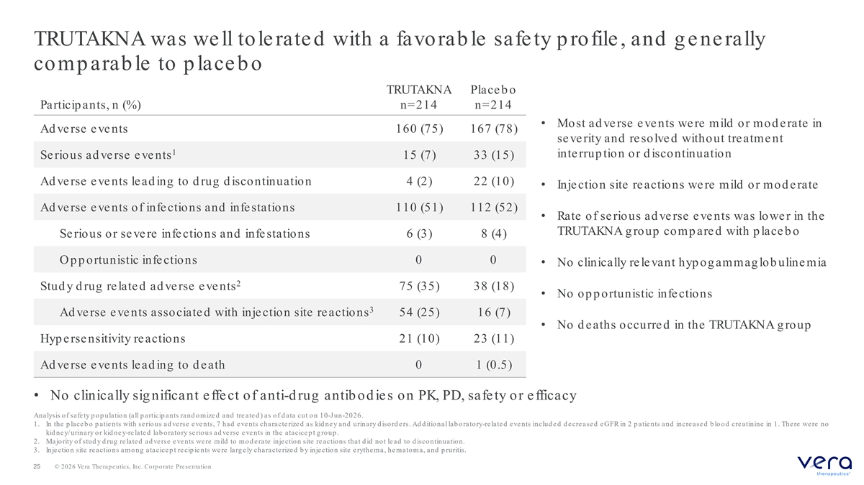
TRUTAKNA was well tolerated with a favorab le safety p rofile, and g enerally comparable to place bo TRUTAKNA Place b o Particip ants, n (%) n=214 n=214 • Most ad verse events were mild or mod erate in Ad verse events 160 (75) 167 (78) se ve rity and re solve d without tre atme nt 1 inte rrup tion or d iscontinuation Serious ad verse events 15 (7) 33 (15) Ad ve rse e ve nts le ad ing to d rug d iscontinuation 4 (2) 22 (10) • Inje ction site reactions we re mild or mod e rate Ad ve rse e ve nts of infe ctions and infe stations 110 (51) 112 (52) • Rate of serious ad verse events was lower in the TRUTAKNA g roup comp are d with p lace b o Se rious or se ve re infe ctions and infe stations 6 (3) 8 (4) O p p ortunistic infe ctions 0 0 • No clinically re le vant hyp og ammag lob uline mia 2 Stud y d rug related ad verse events 75 (35) 38 (18) • No op p ortunistic infe ctions 3 Ad ve rse e ve nts associate d with inje ction site re actions 54 (25) 16 (7) • No d e aths occurre d in the TRUTAKNA g roup Hyp e rse nsitivity re actions 21 (10) 23 (11) Ad verse events le ad ing to d e ath 0 1 (0.5) • No clinically sig nificant effect of anti-d rug antib od ies on PK, PD, safety or efficacy Analysis of safe ty p op ulation (all p articip ants rand omize d and tre ate d ) as of d ata cut on 10-Jun-2026. 1. In the p lace b o p atie nts with se rious ad ve rse e ve nts, 7 had e ve nts characte rize d as kid ne y and urinary d iso rd e rs. Ad d itional lab oratory-related events includ ed d ecreased eGFR in 2 p atients and increased b lood creatinine in 1. There were no kid ne y/urinary o r kid ne y-related lab oratory serious ad verse events in the atacicep t g roup . 2. Majority of stud y d rug re late d ad ve rse e ve nts we re mild to mod e rate inje ction site re actions that d id not le ad to d iscontinuation. 3. Injectio n site reactio ns amo ng atacicep t recip ients were larg ely characterized b y injectio n site erythema, hemato ma, and p ruritis. 25 © 2026 Vera Therapeutics, Inc. Corporate Presentation

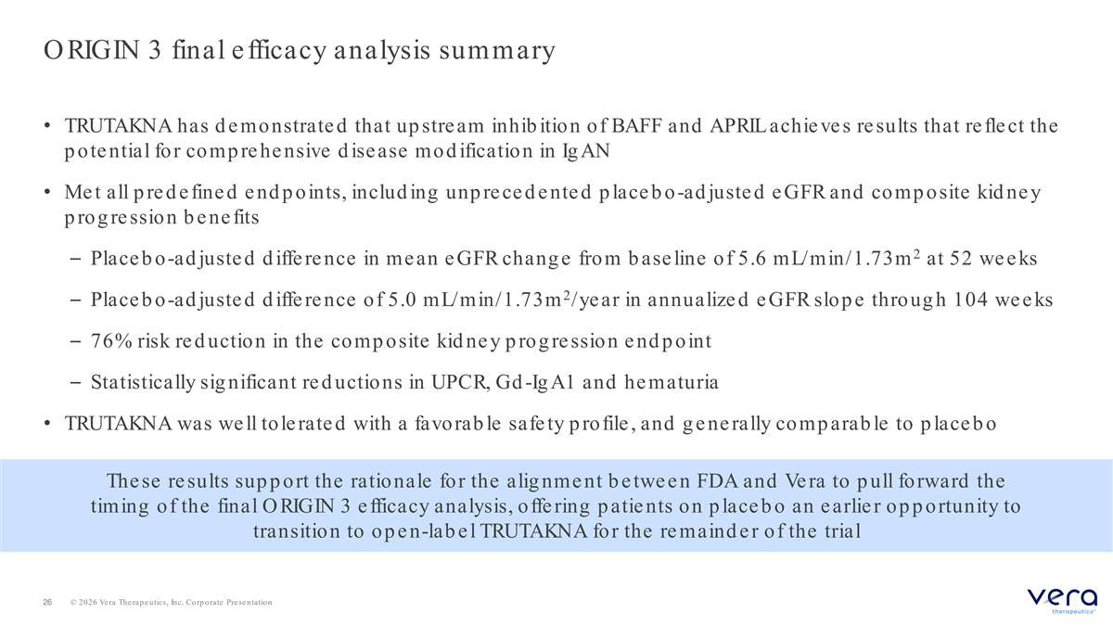
O RIGIN 3 final e fficacy analysis summary • TRUTAKNA has d e monstrate d that up stream inhib ition of BAFF and APRIL achie ve s re sults that re fle ct the p ote ntial for comp re he nsive d ise ase mod ification in Ig AN • Me t all p re d e fine d e nd p oints, includ ing unp re ce d e nte d p lace b o-ad juste d e GFR and comp osite kid ne y p rog re ssion b e ne fits 2 – Place b o-ad juste d d iffe re nce in mean e GFR chang e from b ase line of 5.6 mL/min/1.73m at 52 we e ks 2 – Place b o-ad juste d d iffe re nce of 5.0 mL/min/1.73m /ye ar in annualize d e GFR slop e throug h 104 we e ks – 76% risk re d uction in the comp osite kid ne y p rog re ssion e nd p oint – Statistically sig nificant re d uctions in UPCR, Gd -Ig A1 and he maturia • TRUTAKNA was we ll tole rate d with a favorab le safe ty p rofile , and g e ne rally comp arab le to p lace b o The se re sults sup p ort the rationale for the alig nme nt b e twe e n FDA and Ve ra to p ull forward the timing of the final O RIGIN 3 e fficacy analysis, offe ring p atie nts on p lace b o an earlie r op p ortunity to transition to op e n-lab e l TRUTAKNA for the re maind e r of the trial 26 © 2026 Vera Therapeutics, Inc. Corporate Presentation

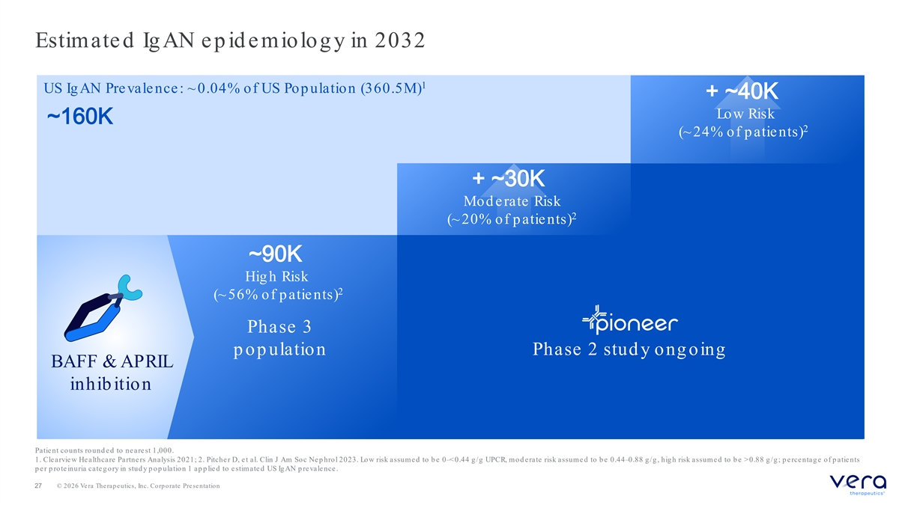
Estimated Ig AN ep id emiolog y in 2032 1 US Ig AN Prevalence: ~ 0.04% of US Pop ulation (360.5M) + ~40K Low Risk ~160K 2 (~ 24% of p atie nts) + ~30K Mod erate Risk 2 (~ 20% of p atie nts) ~90K Hig h Risk 2 (~ 56% of p atie nts) Phase 3 p op ulation Phase 2 stud y ong oing BAFF & APRIL inhib ition Patie nt counts round e d to ne are st 1,000. 1. Cle arvie w He althcare Partne rs Analysis 2021; 2. Pitche r D, e t al. Clin J Am Soc Ne p hrol 2023. Low risk assume d to b e 0–<0.44 g /g UPCR, mod erate risk assumed to b e 0.44–0.88 g /g , hig h risk assume d to b e >0.88 g /g ; p e rce ntag e of p atie nts pe r pro te inuria cate g o ry in study po pulatio n 1 applie d to e stimate d US Ig AN pre vale nce . 27 © 2026 Vera Therapeutics, Inc. Corporate Presentation

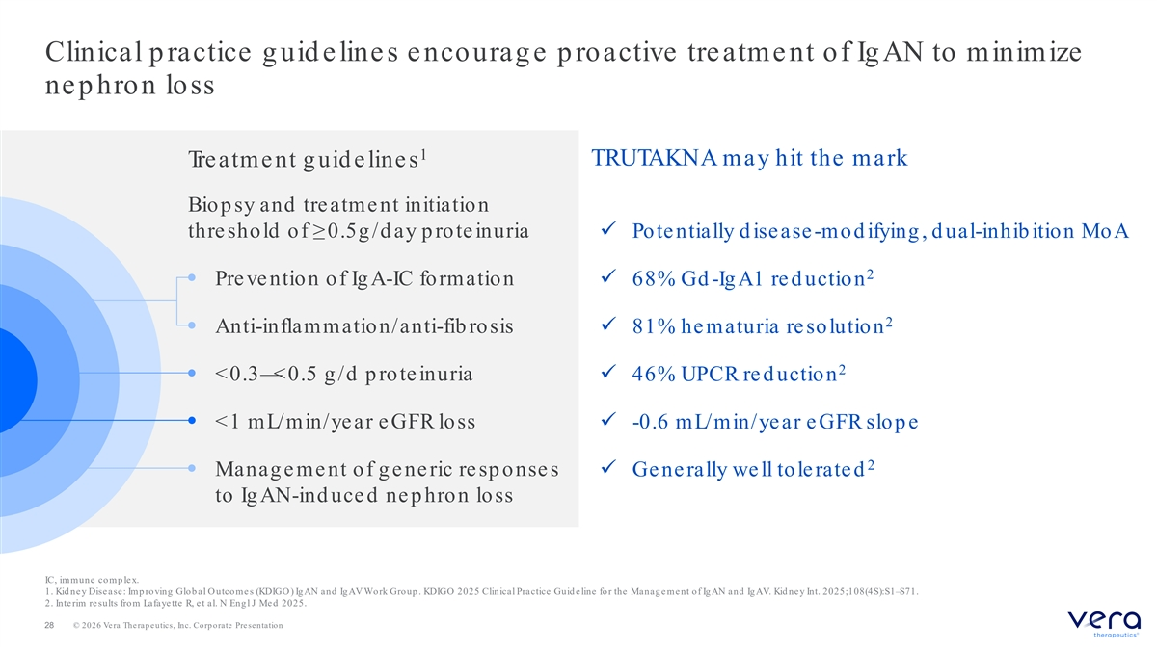
Clinical p ractice g uid elines encourag e p roactive treatment of Ig AN to minimize nep hron loss 1 TRUTAKNA may hit the mark Tre atm e nt g uid e line s Biop sy and treatme nt initiation thre shold of ≥0.5g /d ay p rote inuriaü Pote ntially d ise ase -mod ifying , d ual-inhib ition MoA 2 • Pre ve ntion of Ig A-IC formationü 68% Gd -Ig A1 re d uction 2 • Anti-inflammation/anti-fib rosisü 81% he maturia re solution 2 • <0.3— <0.5 g /d p rote inuria ü 46% UPCR re d uction • <1 mL/min/ye ar e GFR lossü -0.6 mL/min/ye ar e GFR slop e 2 • Manag e me nt of g e ne ric re sp onse s ü Ge ne rally we ll tole rate d to Ig AN-ind uce d ne p hron loss IC, immune comp lex. 1. Kid ne y Dise ase : Imp ro ving Glob al O utcome s (KDIGO ) Ig AN and Ig AV Wo rk Group . KDIGO 2025 Clinical Practice Guid e line for the Manag e me nt of Ig AN and Ig AV. Kid ne y Int. 2025;108(4S):S1–S71. 2. Interim results from Lafayette R, et al. N Engl J Med 2025. 28 © 2026 Vera Therapeutics, Inc. Corporate Presentation

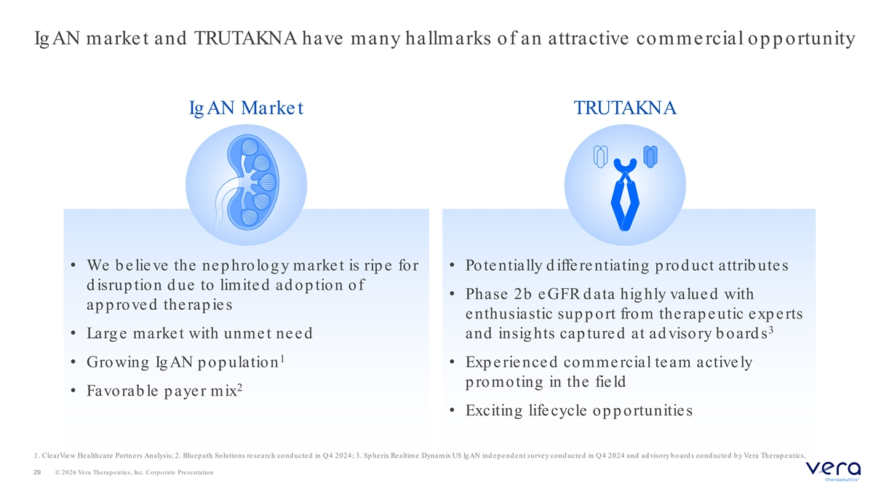
Ig AN marke t and TRUTAKNA have many hallmarks of an attractive comme rcial op p ortunity Ig AN Marke t TRUTAKNA • We b e lie ve the ne p hrolog y marke t is rip e for • Pote ntially d iffe re ntiating p rod uct attrib ute s d isrup tion d ue to limite d ad op tion of • Phase 2b e GFR d ata hig hly value d with ap p rove d the rap ie s e nthusiastic sup p ort from the rap e utic exp e rts 3 • Larg e marke t with unme t ne e d and insig hts cap ture d at advisory boards 1 • Growing IgAN population • Exp e rie nce d comme rcial team active ly p romoting in the fie ld 2 • Favorab le p aye r mix • Exciting life cycle op p ortunitie s 1. ClearView He althcare Partne rs Analysis; 2. Bluep ath So lutio ns re se arch co nd ucte d in Q 4 2024; 3. Sp herix Re altime Dynamix US Ig AN ind e p e nd e nt surve y cond ucte d in Q4 2024 and ad visory b oard s cond ucte d b y Ve ra The rap e utics. 29 © 2026 Vera Therapeutics, Inc. Corporate Presentation

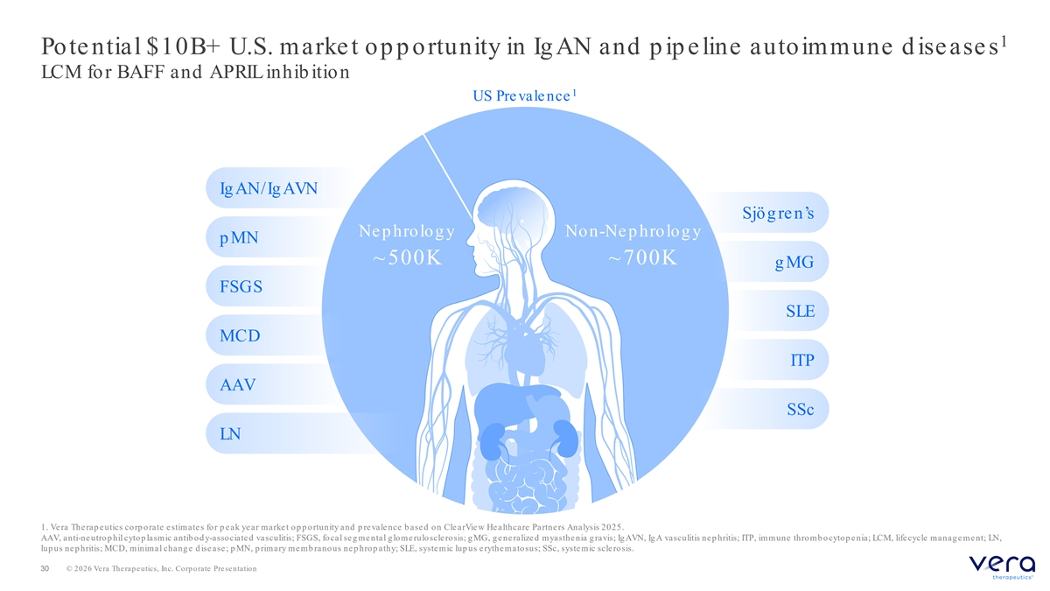
1 Pote ntial $10B+ U.S. marke t op p ortunity in Ig AN and p ip e line autoimmune d ise ase s LCM for BAFF and APRIL inhib ition 1 US Pre vale nce Ig AN/Ig AVN Sjög re n’s Ne p hrolog y Non-Ne p hrolog y p MN ~500K ~700K g MG FSGS SLE MCD ITP AAV SSc LN 1. Vera Therap eutics corp orate estimates for p eak year market op p ortunity and p revalence b ased on ClearView He althcare Partne rs Analysis 2025. AAV, anti-ne utro p hil cyto p lasm ic antib o d y-associate d vasculitis; FSGS, fo cal se g me ntal g lo me rulo scle ro sis; g MG, g e ne ralize d m yasthe nia g ravis; Ig AVN, IgA vasculitis nep hritis; ITP, immune thromb ocytop enia; LCM, lifecycle management; LN, lup us ne p hritis; MCD, minimal chang e d ise ase ; p MN, p rimary me mb ranous ne p hrop athy; SLE, syste mic lup us e rythe mato sus; SSc, syste mic scle ro sis. 30 © 2026 Vera Therapeutics, Inc. Corporate Presentation

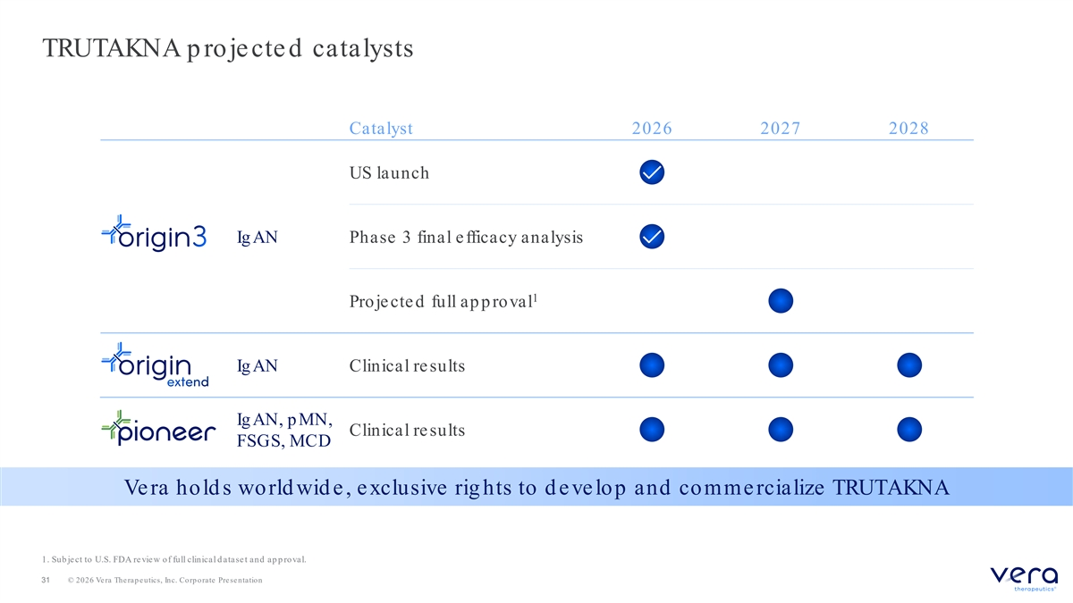
TRUTAKNA p roje cte d catalysts Catalyst 2026 2027 2028 US launch Ig AN Phase 3 final e fficacy analysis 1 Proje cte d full ap p roval Ig AN Clinical re sults Ig AN, p MN, Clinical re sults FSGS, MCD Ve ra hold s world wid e , e xclusive rig hts to d e ve lop and comme rcialize TRUTAKNA 1. Sub je ct to U.S. FDA re vie w of full clinical d atase t and ap p roval. 31 © 2026 Vera Therapeutics, Inc. Corporate Presentation


© 2026 Vera Therapeutics, Inc. Corporate Presentation

